Literacy  Tasty - To retell a fairytale of choice in your own words.  Spicy - Choose your favourite fairytale and change the ending or re-write it from a different character’s perspective.  Hot – write a brand new fairytale. Use other fairytales you know as inspiration. | Literacy  Watch Newsround and tell someone at home about you have heard. Can you write a series of questions about what you have watched and ask someone to answer them. | Literacy  Watch a film of your choice. During or after the film create an 8 box comic strip in the home learning jotter and summarise the events of the film in chronological order. Each box should have a picture and at least 3 sentence. Remember to add colour.  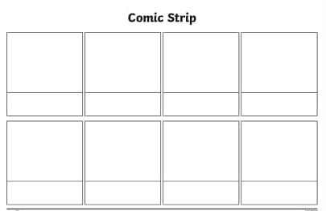
Numeracy  Pick a set of numbers from below and arrange them from the smallest to largest.  Spicy – 72, 77, 39, 93, 95, 97  Hot – 3455, 3554, 3454, 4355, 4553, 3545  Tasty – 101432, 101342, 101422, 101423, 101,422, 101232, 101322 | Numeracy  Have a practise of the times table you know the least. Can you use these and make the multiplication and division families. i.e. 2x4=8, 4x2=8  8÷2=4, 8÷4=2 | Maths  Go on a right angle hunt. Write down as many as you can find.  Can you name any other types of angles? Can you create a poster about these?  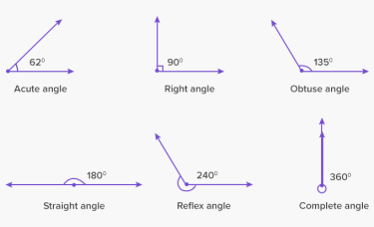
HWB  Look at this clip. https://www.youtube.com/watch?v=DWOHcGF1Tmc Follow the instructions and then design your own happy place. | HWB  Your job is to help your parent this week. Can you take one of the jobs from them and complete it. It might be making them a cup of tea, helping with the dishes or laundry or setting the table. | HWB  1.Do something that makes you happy. Spend at least 30 minutes doing this. It might be a dance, playing on a console, reading, drawing or watching TV.  2.Write 5 things you are grateful for in your Home learning book with the date at the top of the page.

