Literacy – Reading  1. L.I. I can read with increasing fluency and understanding.  Children who have finished RWI please read a book of your choice and do an AR test. Remember, if you’re reading a Chapter book it may take you all week to read your book but it is important that you don’t rush to do the test or you won’t get very good marks. We are looking for 9/10 or 4/5! If you are reading a shorter book then you can challenge yourself to read more than one book.  As an extension activity you could write a summary of the last chapter you have read. Happy reading!  Read Write Inc  A detailed RWI task sheet is available for you in Google Classroom.  When accessing the e-books you can now use your class login and follow the link on your task sheet to read the assigned book.  P4 login name: Primary4cps  P4 password: p4cps  If you do not have access to Google Classroom then you can;  - Watch the Daily Set Speed Sounds and Word Time videos on YouTube through the link below;  Ruth Miskin You Tube  - Play the literacy games set for you on Education City (check your Classwork section).  - Enjoy reading stories with a grown up and talk about what happens in the story.  2. L.I. I can find, select, sort and use information from a text.  This week I’ve included an excerpt from The Lion, the Witch and the Wardrobe by C.S. Lewis for you to read. This book is part of the Chronicles of Narnia books. Please read it carefully or you could get someone to help you if you are finding it tricky. Once you have done this answer the questions in complete sentences. There are 3 levels to choose from Mild, Spicy and Hot. Only do the one you think is the best for you.  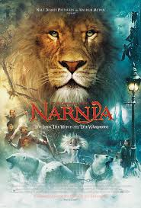 | Literacy – Writing / Grammar  1. L.I. I can write independently, use appropriate punctuation and order and link my sentences in a way that makes sense.  This week you are going to write about your week. I’ve included a storyboard for you to use. You can either tell me about 6 things you did on 1 day or use it like a diary and write about the things you did on each day of the week. I’ve only include 6 sections for this task. Remember to draw me a picture that goes with each piece of writing. I’ve included a short video to help you with this task.  2. I can find and identify nouns, verbs and adjectives.  As a result of feedback from some of you regarding the grid, I thought I’d include some word searches for you this week. I’ve made up 3 for you to try. 1 is about nouns, 1 is verbs and the last 1 is adjectives. You can do all 3 if you wish. Happy hunting!! | Numeracy  L.I. I have investigated how whole numbers are constructed, can understand the importance of zero within the system and can use my knowledge to explain the link between a digit, its place and its value.  This week we are going to look at numbers. There are 3 sheets to choose from, Mild, Spicy and Hot. Each sheet uses different numbers. Some are 10 and 1s, some 100s, 10s and 1s and the final ones use 1000s, 100s, 10s and 1. You can choose to do all of them or just some of them, it’s up to you. The most important thing is to do some of them. Good luck!!  2. L.I. I can use digital technology to support and enhance my learning.  Use the links to play games which concentrate on place value.  https://www.topmarks.co.uk/learning-to-count/place-value-basketball  http://www.ictgames.com/sharkNumbers/mobile/  https://uk.splashlearn.com/place-value-games-for-year-4  https://uk.splashlearn.com/place-value-games-for-year-3
Maths  1. L.I. I can use informal methods to measure and describe the size of angles in relation to right angles.  This week we are going to start to look at lines and angles. There are 3 levels to choose from, Mild, Spicy and Hot and each level has 2 sheets for you to try. If you really want to challenge yourself you could do more than 1 level. I’ve included a short video to help you with these tasks.  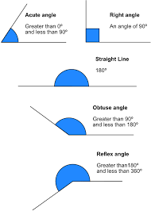  2. L.I. I can use digital technology to support and enhance my learning.  To help you recognise and draw different angles have a go at these angles games. The first one has different levels and the second one can be a bit tricky but they’re fun once you get the hang of them!!  https://mathsframe.co.uk/en/resources/resource/470/Angle-Alien-Attack  https://www.mathplayground.com/alienangles.htm  l | HWB  Once again I have included some PE lessons from Mrs Tait the PE Specialist.  L.I. I can move my feet quickly and keep my balance,  ⚽Football Toe Taps⚽  How quickly can you tap a football with your toes? First Do it...Then do it right….Last do it fast! This is great for fast feet and agility! What you do: Find a space – indoors or outdoors. Use a larger ball such as a football or a step. Tap your toes on the ball one foot at a time – left, right. Try and keep the ball in the same place. Try and touch it lightly with the sole of your feet. Make sure you look at the ball and keep good balance.  Challenge How many taps can you do in 30 seconds alternating right foot and left. How quickly can you reach 30, 40, 50 toe taps.  2. L.I. I know that friendship, caring, sharing, fairness, equality and love are important in building positive relationships. As I develop and value relationships, I care and show respect for myself and others.  Acts of kindness are important and help us create strong relationships with our family members and friends. This week I am going to challenge you to carry out 1 act of kindness every day. This can be helping your mum put away the shopping, tiding your bedroom, doing the dishes or setting the table for dinner. It doesn’t really matter what you do as long as whoever you are helping doesn’t know. You need to just do it without being asked. While you are carrying out your act of kindness think how the other person feels. How do you feel? Each day try to put a comment on Google Stream to tell everyone what you have done and how it made you feel. | French  1. L.I. I can use digital technology to support and enhance my learning.  We are going to move on to days of the week and months of the year. I’ve included some links to games you can play to help you remember them.  https://www.lightbulblanguages.co.uk/estrellas-french-index.htm#days  https://primarygamesarena.com/Play/Days-and-months-in-French-lang-2136  2. I can read, say and individual the days of the week and month of the year in French.  To help you remember what you have learned playing the games, I have included 2 French worksheets for you to do. You have to match the day or month in French with the English word. Bonne Chance!  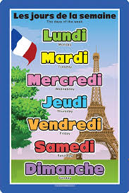
Family Learning  I know you all like to play family games so here is one that Mrs Tait suggested. It’s basically Bowling but using stuff that you have in your house. Use old plastic bottles with a little water or rice or sand in the bottom to weigh them down as skittles. Take turns at rolling a ball to knock them down. You can draw numbers on the skittles and use your math’s skills to keep a tally of the total number scored if you want. I wonder who will win.  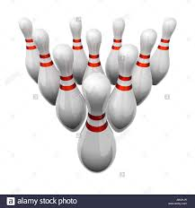  Pancakes  Tuesday 16th February was pancake day. Pancake day or Shrove Tuesday marks the beginning of run up to Easter. This week I’ve included a recipe for pancakes for you to try. Remember to post a picture on the stream to let everyone see how you got on making pancakes.  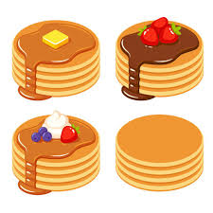 | Learning Across the Curriculum  1. L.I. I am becoming aware of the journeys which foods make from source to consumer, their seasonality, their local availability and their sustainability.  Use the links provided to watch 2 short films on Fairtrade. Have a discussion with your adults about whether they buy Fairtrade foods or not. Have a look in your kitchen for foods that have the Fairtrade logo on them. Do your adults buy them because they are Fairtrade? Are they more expensive? What types of foods do they buy that are Fairtrade?  https://schools.fairtrade.org.uk/teaching-resources/cocoa-climate-a-lesson-plan-for-primary-schools/  https://schools.fairtrade.org.uk/teaching-resources/change-the-world-through-your-choices/  2. Complete the worksheet about Fairtrade Cocoa. You will need to really listen to what is said in the video to help you fill it in correctly.  I’ve included a short video to help you with the tasks I’ve set. | Learning Across the Curriculum  1. L.I. Through exploring Bible stories, I can describe some beliefs Christians have about God and Jesus.  Last Tuesday was Shrove Tuesday or Pancake Day. This day marks the beginning of Lent. Use the link to watch a short film about Lent and the different things that happen on the run up to Easter. Once you have done this think about something that you would give up or do for the 40 days before Easter. It could be to give up chocolate, be kind, stop playing on your tablet or games console. Think about how hard that would be. Once you have thought about it, try to do it for a few days. Did you manage to do it? How hard was it? Do you think you’d manage to do it for 40 days? Try to get your adult to do it too. I wonder what they would give up.  https://www.youtube.com/watch?v=-4ZuiMdCH7w  2. L.I. I can sort living things into groups and explain my decisions.  This week we are going to look at what different animals eat. Use the link below to watch a short film about what different animals eat. Once you have done that there is a short quiz to check your understanding of what you have watched. I’ve also included a worksheet for you to complete. Remember to post your work on the Classroom for me to see.  https://www.bbc.co.uk/bitesize/topics/z6882hv/articles/z96vb9q

Animals - What They Eat

Animals need to__________ so they can stay _____________. Food is the main source of _________________ for all animals. ______________ types of animals eat different _______________. We can group animals based on the _____________ of food they like to _________. There are some animals that only eat ____________. These animals are called __________________. Other animals only eat ___________. They are called ________________. There are some animals that eat both _______________ and ____________. These animals are called ________________. There are lots of different ____________ which can be sorted into one of these 3 _______________.

groups | plants | omnivores | types
meat | animals | foods | eat
plants | different | energy | meat
foods | carnivores | eat | alive

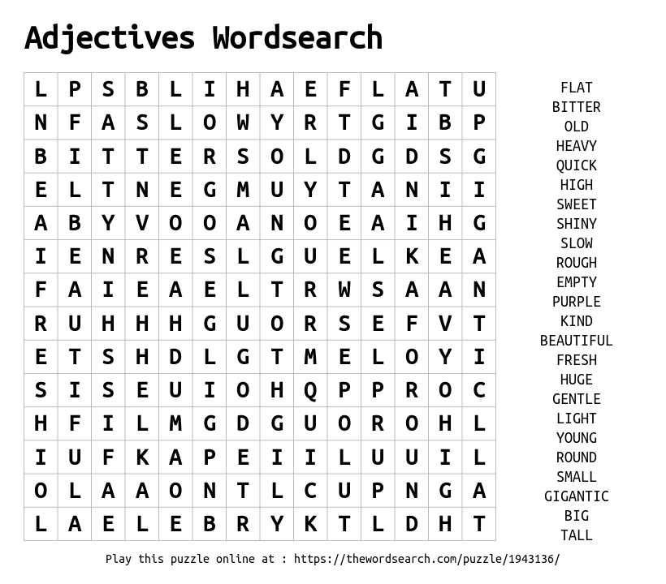
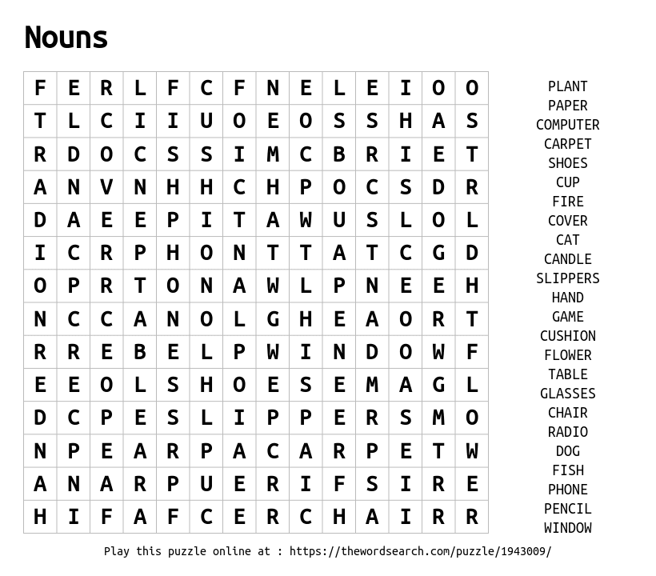

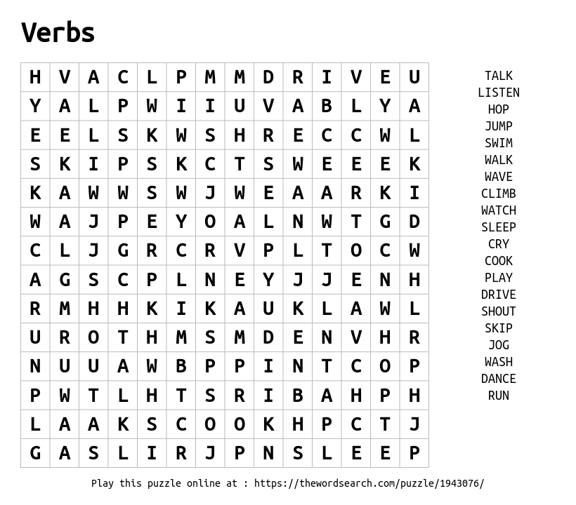

Match the day of the week in English to the day of the week in French.
One has been done for you↕

Monday Tuesday Wednesday

Mardi | Lundi | Mercredi

Dimanche | Samedi | Jeudi | Vendredi

Thursday Friday Saturday Sunday

French Months of the Year

Write the month of the year next to the French word.
Remember our months start with a capital letter.

janvier
novembre
juin
septembre
fevrier
mai
aout
avril
decembre
juillet
octobre
mars

MILD
Extract from The Lion, the Witch and the Wardrobe by C.S.Lewis.

The Queen took from somewhere among her wrappings a very small bottle which looked as if it were made of copper. Then, holding out her arm, she let one drop fall from it onto the snow beside the sledge. Edmund saw the drop for a second in mid-air, shining like a diamond. But the moment it touched the snow there was a hissing sound and there stood a jewelled cup full of something that steamed.

Q1. What did the Queen take from her wrappings?

A1.

Q2. What did she let drop onto the snow?

A2.

Q3. What did the droplet look like in mid air?

A3.

Q4. What noise did it make as it hit the snow?

Q4.

Q5. What did the droplet turn into?

A5.

SPICY - Extract from The Lion, the Witch and the Wardrobe by C.S.Lewis.
The Queen took from somewhere among her wrappings a very small bottle which looked as if it were made of copper. Then, holding out her arm, she let one drop fall from it onto the snow beside the sledge. Edmund saw the drop for a second in mid-air, shining like a diamond. But the moment it touched the snow there was a hissing sound and there stood a jewelled cup full of something that steamed. The dwarf immediately took this and handed it to Edmund with a bow and a smile; not a very nice smile. Edmund felt much better as he began to sip the hot drink. It was something he had never tasted before, very sweet and foamy and creamy, and it warmed him right down to his toes.

Q1. What did the Queen take out of her wrappings?
A1.
Q2.How many drops did she let fall onto the snow?
A2.
Q3. What did Edmond think the droplet shone like?
A3.
Q4. What kind of noise did the drop make when it hit the snow?
A4.
Q5. What object did the drop make in the snow?
A5.
Q6. Who picked up the cup and gave it to Edmund?
A6.
Q7. What 2 things did the dwarf do when he gave the cup to Edmund?
A7.
Q8. How did Edmund think the drink taste?
A8.

HOT Extract from The Lion, the Witch and the Wardrobe by C.S.Lewis.
The Queen took from somewhere among her wrappings a very small bottle which looked as if it were made of copper. Then, holding out her arm, she let one drop fall from it onto the snow beside the sledge. Edmund saw the drop for a second in mid-air, shining like a diamond. But the moment it touched the snow there was a hissing sound and there stood a jewelled cup full of something that steamed. The dwarf immediately took this and handed it to Edmund with a bow and a smile; not a very nice smile. Edmund felt much better as he began to sip the hot drink. It was something he had never tasted before, very sweet and foamy and creamy, and it warmed him right down to his toes. “It is dull , Son of Adam, to drink without eating,” said the Queen presently. “What would you like best to eat?”
“Turkish Delight, please, your Majesty,” said Edmund.
The Queen let another drop fall from her bottle onto the snow, and instantly there appeared a round box, tied with green silk ribbon, which, when opened, turned out to contain several pounds of the best Turkish Delight. Each piece was sweet and light to the very centre and Edmund had never tasted anything more delicious. He was quite warm now, and very comfortable.
Q1. What did the Queen take out of her wrappings?
A1.
Q2.How many drops did she let fall onto the snow?
A2.
Q3. What did Edmond think the droplet shone like?
A3.
Q4. What kind of noise did the drop make when it hit the snow?
A4.
Q5. What object did the drop make in the snow?
A5.
Q6. Who picked up the cup and gave it to Edmund?
A6.
Q7. What 2 things did the dwarf do when he gave the cup to Edmund?
A7.
Q8. How did Edmund think the drink taste?
A8.
Q9. What did Edmund want to eat?
A9.
Q10. What did the box of Turkish Delight look like?
A10.
Q11. How did each piece of Turkish Delight taste?
A11.
Q12. How did Edmund feel after having something to eat and drink?
A12.

Complete each activity on the grid – these can be completed in Green Jotter you were given.

