Literacy – Reading  1. L.I. I can read with increasing fluency and understanding.  Children who have finished RWI please read a book of your choice and do an AR test. Remember, if you’re reading a Chapter book it may take you all week to read your book but it is important that you don’t rush to do the test or you won’t get very good marks. We are looking for 9/10 or 4/5! If you are reading a shorter book then you can challenge yourself to read more than one book.  As an extension activity you could choose 10 interesting words from the part you have read so far and find the meanings of these words in a dictionary. If you don’t have a dictionary at home use your phone or laptop or tablet to look up the meanings. Write the word and what it means in your jotter. Happy reading!  Read Write Inc  A detailed RWI task sheet is available for you in Google Classroom.  When accessing the e-books you can now use your class login and follow the link on your task sheet to read the assigned book.  P4 login name: Primary4cps  P4 password: p4cps  If you do not have access to Google Classroom then you can;  - Watch the Daily Set Speed Sounds and Word Time videos on YouTube through the link below;  Ruth Miskin You Tube  - Play the literacy games set for you on Education City (check your Classwork section).  - Enjoy reading stories with a grown up and talk about what happens in the story.  2. L.I. I can find, select, sort and use information from a text.  This week I’ve included an excerpt from Code Name Bananas by David Walliams for you to read. Please read it carefully or you could get someone to help you if you are finding it tricky. Once you have done this answer the questions in complete sentences. There are 3 levels to choose from Mild, Spicy and Hot. Only do the one you think is the best for you.  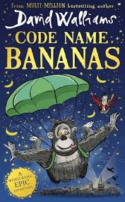 | Literacy – Writing / Grammar  1. L.I. I can create a text for a given purpose.  This week you are going create a poster about Fair Trade. Use the link below to watch a short video about Fair Trade (Tipping the Balance) and then create a poster to show what you have learned. Remember a poster has to have bold writing, is easily read, has illustrations and is interesting to look at and read. Check your spelling and make sure the message is easily understood. Post a picture of your poster on the classroom or stream for me to see. I’ve created a short video to help you with this task.  https://www.youtube.com/watch?v=B45_I1TUlSs  2. I can identify and use different types of words.  This week we are going to do some work on collective nouns. We all know that a noun is the name of a person, place or thing but some groups of things have a special name. Some examples of this is a herd of cows, a deck of cards and a bunch of flowers. To help you learn more about collective nouns, watch the short video using the link provided and then complete the worksheet. Some of them are harder than others and you may need a bit of help from an adult. Good luck!  https://www.youtube.com/watch?v=zijGfIzT5Ss  A gaggle of geese! | Numeracy  L.I. I have investigated how whole numbers are constructed, can understand the importance of zero within the system and can use my knowledge to explain the link between a digit, its place and its value.  This week we are going to continue looking at numbers. Once again there are 3 different levels of sheets for you to choose from (Mild, Spicy and Hot) and each level has 2 sheets. The sheets are all different so if you really want to challenge yourself you could do all 6 sheets!! Wow, I would really be impressed if you did that!!  2. L.I. I can use digital technology to support and enhance my learning.  I know that you all love a Sumdog Competition and amazingly a new competition starts this week. Now last time P4B were the winners and each person who entered and was part of the winning team received 5000 coins each!!! Imagine what you would spend all those coins on! The competition starts on 26th of February and runs to 4th March. Good luck everyone
Maths  1. L.I. I can use informal methods to measure and describe the size of angles in relation to right angles.  This week we are going to continue to look at lines and angles. There are 3 different level of sheets, Mild, Spicy and Hot. Each level has 2 sheets for you to do. If you really want to challenge yourself you could do more than one level.  2. I can name and identify a variety of 2D shapes.  Use the link to watch a short video about lots of different shapes and then go on shape hunt around your house to see how many of these different shapes you can spot. Are there any shapes that you didn’t see? How many of these shapes have a right angle in them? You could use your right angle template from the previous task to help you. Happy shape hunting! (I’ve included a right angle checker template for those who didn’t get the chance to make one!) I’ve also included a short video to explain this task further.  https://www.youtube.com/watch?v=E6qWBhEiP6g | HWB  1. I can demonstrate a range of non-verbal communication skills.  Think of an action you could make when saying your name e.g punch the air; clap two times; tap your chest; kick R, kick L; ……. Say your name with confidence and add the associated movements. Ask everyone in your house to make up their own action and see if everyone can remember each other’s action. Instead of saying someone’s name to get their attention, you could do their action!!  2. I can keep going when faced with a challenge and work to achieve a successful outcome.  Place a hoop or a piece of cardboard about 3 steps away from you. Using a ball or rolled up socks Throw underarm at the ‘target’. If you hit the target ‘flip’ it over away from you and try again. How far can you move the target in 1 minute? How far can you move the target in 20 throws? Top Tip: Opposite arm, opposite leg-right arm left leg forward. Follow through and take time | French  1. I can explore aspects of life and culture through festivals.  French Fridays will be live online every Friday at 11.00 on our Youtube channel, Lingobox Learning. Each week for the spring term will have a different theme! ·The sessions are recorded so can be watched at any time! ·Each live session lasts 15 to 20 minutes. Links in the titles below! • Extra videos will be shared to the playlists on the dates listed. The playlist links are in the week titles below! Week 1: Le Mardi Gras!  2. I am beginning to develop and awareness of France and French culture.  Tuesday 16th February – How to make a crêpe en français! Thursday 18th February – Learn how to make a carnival mask en français!  You can follow us on: Twitter: @Lingobox Facebook: @LingboxLearning Instagram: @LingboxLearning Or subscribe to us on Youtube: Lingobox Learning!
Family Learning  1. One of the things that I am asked to do in class on a regular basis is to tie someone’s laces. This week I’d like you to learn to tie your laces. You are going to need a bit of help and time to practice but it’ll be worth it once you get the hang of it. I’ve included a step by step guide to help you. Remember practice makes perfect!  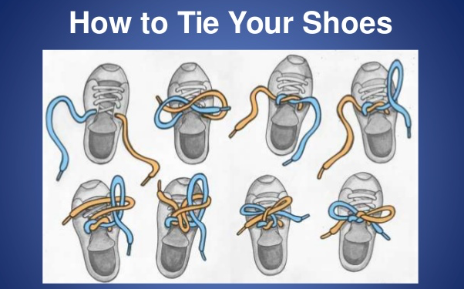  2. Some of you are become quite the dab hand at baking, so this week I’ve included a recipe for scones. Remember to post a picture on the stream or classroom to show us all how fabulous you are at baking!!! | Learning Across the Curriculum  1. I am developing respect for others and my understanding of their beliefs and values.  Easter is celebrated throughout the world and each country has its own special way to celebrate. In Bermuda they make kites and fly them on Good Friday. In Bermuda this day is known as the kite day. Your task is to make and decorate a kite to fly outside. I’ve included some short videos to show you how to make a kite in different ways. Maybe the adult who is going to help you already knows a way to make a kite! Once you have done this decorate it and try to fly it outside. If you can, take a photo of you and your kite and post it on the stream or classroom. Good luck, happy kite making!!  https://www.youtube.com/watch?v=-lmfwarW88E  https://www.youtube.com/watch?v=oQJYnvAmcCY  https://www.youtube.com/watch?v=t96s74TKkMo  https://www.youtube.com/watch?v=WiPpSI257tw  2. L.I. I am becoming aware of the journeys which foods make from source to consumer, their seasonality, their local availability and their sustainability.  As this is Fair Trade Fortnight, we are going to continue to learn a bit more about Fair Trade and what it means to other people.  https://schools.fairtrade.org.uk/teaching-resources/virtual-visit-from-a-fairtrade-speaker/  Once you have listened to and watched the video have a go at the quiz I’ve made.  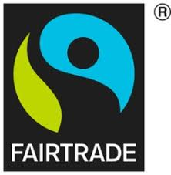 | Learning Across the Curriculum  1. L.I. I can sort living things into groups and explain my decisions.  We are going to continue to learn about different animals. This week we are going to concentrate on habitats and the special names animals are given depending on where they live. Watch the Dr Binocs video then complete the word search.  https://www.youtube.com/watch?v=5hFoZq0qgrM  2. I can explore the latest technologies and develop my skills of how to use them.  I have provided the link to a few computer skills games for you to try. They will help you with your typing skills. Some of the games are timed so you will have to type fast!!! Good luck I’ve created a short video to explain how I want you to do this task.  https://www.typing.com/student/games  https://www.typing.com/student/game/keyboard-ninja  https://www.nitrotype.com/race  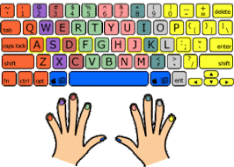

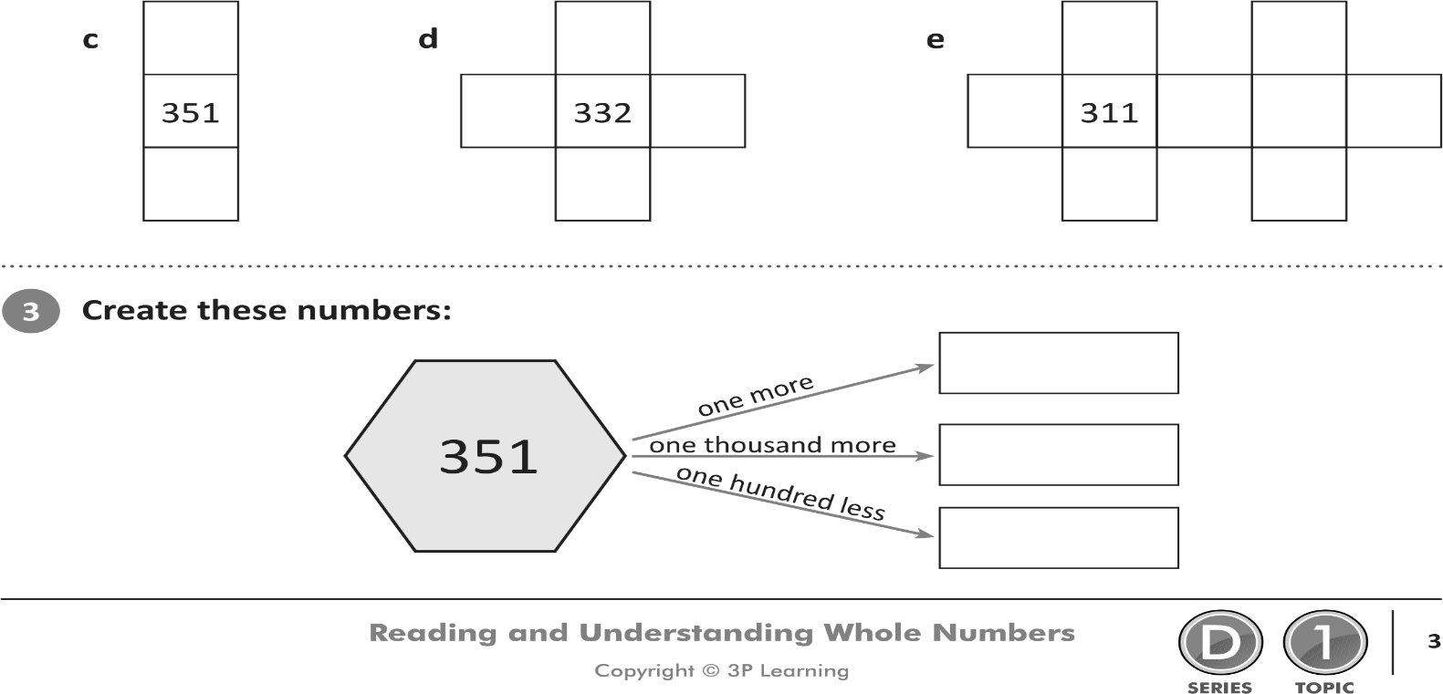
[Grab your reader’s attention with a great quote from the document or use this space to emphasize a key point. To place this text box anywhere on the page, just drag it.]
SPICY CONTINUED

Easy Scones
Ingredients:
225g self raising flour
55g butter or marg
25g caster sugar
25g sultanas (optional)
150 ml milk
pinch of salt
milk to glaze
Instructions:
Preheat the oven to 220 degrees Celsius or gas mark 7
Mix together the flour and salt and then rub in the butter.
Stir in the sugar and sultanas if using and then the milk to make a soft dough.
Turn dough out onto a floured work surface and knead very lightly.
Pat out to a height of roughly 2cm
Use a small cutter to stamp out rounds and place on a baking sheet.
Lightly knead together the rest of the dough and stamp out more scones to use it all up.
Brush the tops of the scones with a little milk.
Bake for 12-15 minutes until well risen and golden.
Once cool, spread with butter and jam and eat
FAIRTRADE FORTNIGHT 2021 QUIZ
Circle the correct answer.
1. Chocolate bars are made from cocoa beans. True/False
2. Cocoa trees grow best in freezing temperatures. True/False
3. All humans need healthy food to live. True/False
4. All humans need a car to live. True/False
5. Fair Trade farmers are given a living wage for their product. True/False
6. All Fair Trade products have the Fair trade mark on them. True/False
7. Fair Trade farmers receive a Fair Trade premium for their product. True/False
8. Most Fair Trade products are grown near the Equator. True/False
9. The temperature of the Earth is getting hotter. True/False
10. You can make a difference by buying Fair Trade products. True/False

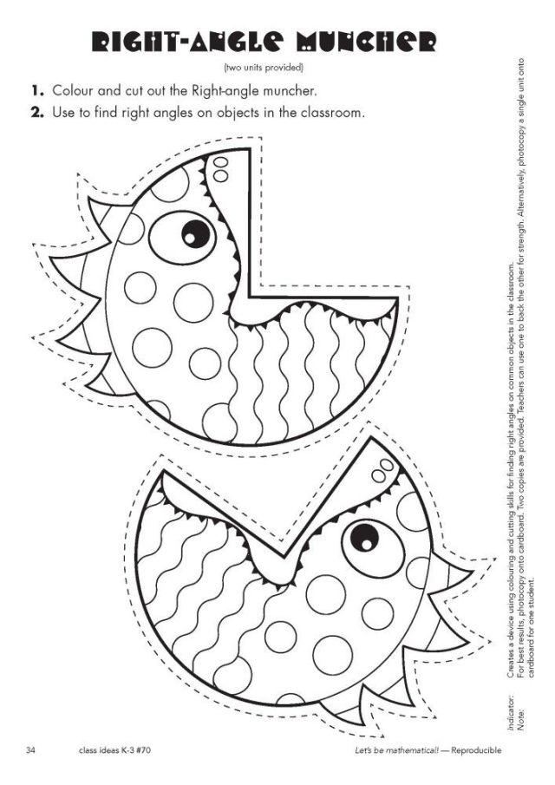
HOT Extract from Code Name Bananas By David Walliams
Our adventure begins on a cold, crisp afternoon in London in December 1940. In London Zoo, to be precise. There, a little boy had just made a discovery. A discovery that made him laugh for the first time in a long, long time. That little boy was an eleven-year-old orphan named Eric. He was short for his age and had sticky-out ears, which made him feel like he stuck out. The boy wore glasses, but one of the lenses was cracked, and he didn’t have any money to repair them. As soon as the bell rang for the end of school, Eric would run out of the gates as fast as his little legs would take him. He hated school, where he was picked on mercilessly for his sticky-out ears, and given the nickname”Wingnut”. Eric has been given strict orders by his grandmother to hurry straight home. But he couldn’t resist taking a detour. From school, he dashed through the streets, dodging the mountains of rubble. There were adventures to be had in the wreckage of downed Nazi planes, burnt out double decker buses or bombed buildings, but the boy didn’t dilly dally. Oh no. He was in a rush to get to his favourite place on earth. London Zoo. Apart from the animals, the best thing about the zoo was that Eric could get in for FREE! That was because his uncle worked there as a zookeeper. Uncle Sid was really mum’s uncle, but Eric always called the old man “Uncle Sid” too. Sometimes Eric would even help Sid with his work. This he loved more than anything. His dream was to be a zookeeper himself one day. To Eric, animals seemed so much nicer than humans. None of them made fun of his sticky-out ears for a start. Some of them had sticky-out ears too. No matter, they were all beautiful in their own way.
Q1. When does the adventure begin?
A1.
Q2. How old was Eric?
A2.
Q3. Describe how Eric looked.
A3.
Q4. What was Eric’s nickname?
A4.
Q5. Who told Eric he must go straight home?
A5.
Q6. Name 3 thing Eric would see on his way to London Zoo.
A6.
Q7. Apart from the animals, what was the other great thing about going to the Zoo?
A7.
Q8. What job did Uncle Sid do?
A8.
Q9. What did Eric sometimes do when he went to the zoo?
A9.
Q10. What did Eric think about the animals?
A10.

SPICY
Extract from Code Name Bananas By David Walliams
Our adventure begins on a cold, crisp afternoon in London in December 1940. In London Zoo, to be precise. There, a little boy had just made a discovery. A discovery that made him laugh for the first time in a long, long time.
That little boy was an eleven-year-old orphan named Eric. He was short for his age and had sticky-out ears, which made him feel like he stuck out. The boy wore glasses, but one of the lenses was cracked, and he didn’t have any money to repair them.
As soon as the bell rang for the end of school, Eric would run out of the gates as fast as his little legs would take him. He hated school, where he was picked on mercilessly for his sticky-out ears, and given the nickname”Wingnut”.
Eric has been given strict orders by his grandmother to hurry straight home. But he couldn’t resist taking a detour. From school, he dashed through the streets, dodging the mountains of rubble. There were adventures to be had in the wreckage of downed Nazi planes, burnt out double decker buses or bombed buildings, but the boy didn’t dilly dally. Oh no. He was in a rush to get to his favourite place on earth. London Zoo.

Q1. What time of day was it when the adventure began?
A1.
Q2. Where exactly is the story set?
A2.
Q3. How old is Eric?
A3.
Q4. What does Eric look like?
A4.
Q5. Why couldn’t Eric repair his glasses?
A5.
Q6. What was the nickname he was given at school?
A6.
Q7. Name 3 things Eric saw in the rubble?
A7.
Q8. Where was Eric heading to straight after school?
A8.
MILD
Extract from Code Name Bananas By David Walliams
Our adventure begins on a cold, crisp afternoon in London in December 1940. In London Zoo, to be precise. There, a little boy had just made a discovery. A discovery that made him laugh for the first time in a long, long time.
That little boy was an eleven-year-old orphan named Eric. He was short for his age and had sticky-out ears, which made him feel like he stuck out. The boy wore glasses, but one of the lenses was cracked, and he didn’t have any money to repair them.

Q1. What time of day was it when the adventure began?

A1.

Q2. Where exactly is the story set?

A2.

Q3. How old is Eric?

A3.

Q4. What does Eric look like?

A4.

Q5. Why couldn’t Eric repair his glasses?

A5.

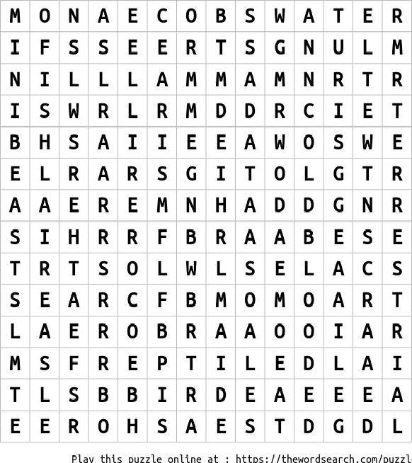
ANIMALS HABITATS

FISH REPTILE
ARBOREAL SCALES
MAMMAL WARM BLOODED WINGS
COLD BLOODED MINIBEAST AIR GILLS RAINFOREST TERRESTRIAL
SEASHORE BIRD LUNGS FEATHERS EGGS OCEAN MEADOW WATER AERIAL TREES DESERT

