Literacy – Reading  World Book Week - The Masked Reader  LI: I am learning to read with increasing fluency, expression and understanding.  Look out a mask, or dress up as a character from the book and to somewhere inconspicuous, somewhere that would make it tricky for others to guess it is you. Record yourself reading a passage from the book (maybe in a funny voice) and upload it to Google Classroom and we will guess who the masked reader is.  Read Write Inc  LI: I am learning to use the sounds I need to help me read unknown texts.  A detailed RWI task sheet is available for you in Google Classroom.  When accessing the e-books you can now use your class login and follow the link on your task sheet to read the assigned book.  P5 login name: Primary5cps  P5 password: p5cps  If you do not have access to Google Classroom then you can;  - Watch the Daily Set Speed Sounds and Word Time videos on YouTube through the link below;  Ruth Miskin You Tube  https://www.youtube.com/channel/UCo7fbLgY2oA_cFCIg9GdxtQ  - Play the literacy games set for you on Education City (check your Classwork section).  - Enjoy reading stories with a grown up and talk about what happens in the story.  - Play the literacy games set for you on Education City (check your Classwork section).  - Enjoy reading stories with a grown up and talk about what happens in the story.  AR – Learners not using RWI  LI: I am learning to read with increasing fluency, expression and understanding.  Throughout the course of this week, read a book of your choice. Don’t rush the book as it is important that you understand what is going on in the book. Whilst the majority of the book you will read silently to yourself, take some time to read part of the book to someone in your house, that way you are practicing reading with fluency and expression.  Challenge: To get at least 9/10 or 4/5 when testing.  Bloom’s Reading Detective  LI: I am learning about the structure and organisation of texts.  Using your personal reading book choose at least one of the questions below and answer. Remember to write in sentences using the correct punctuation.  Challenge: Answer more than one question.  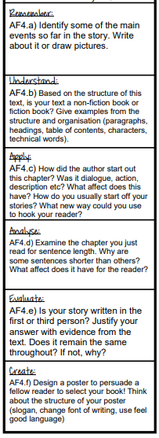 | Literacy – Writing / Grammar  Imperative (bossy) verbs  LI: I am learning what an imperative verb is and how to use it.  Imperative verbs are also known as ‘bossy verbs’ because they tell people what to do! E.g. Shut the window or turn the kettle on.  Complete the two worksheets and wordsearch. These tasks will help you to complete your writing task this week.  Writing – Instructions  LI: I can write instructions.  Watch this short YouTube clip on instructions: https://www.youtube.com/watch?v=FN2RM-CHkuI  Take what you have learnt from this clip and write your own set of instructions on how to make a sandwich of your choice. If you are in need for some inspiration, have a go at the sandwich generator game and create your sandwich using that. This can be found at the bottom of the grid or in google classroom.  Success Criteria:  - A clear title  - Lists (e.g. materials/ingredients,equipment)  - Numbers to show clear order.  - Use imperative (bossy) verbs.  - Use connective (first, next)  - Short, clear sentences.  - Diagrams/illustrations.  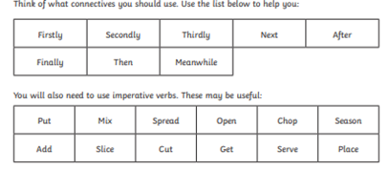  Refer to the bottom of the grid or google classroom for an example and writing template. There is also a PowerPoint available on google classroom with further support and guidance. | Numeracy  Mental Maths  We have developing our speed and accuracy in oral calculations.  There are two Mental Maths activities for you to do in Google Classroom. One is a problem solving activity and the other a set of questions to help you develop skills in all areas of numeracy.  There are three, mild, spicy and hot so that everyone can choose the ones which are best for them. Copies are attached for anyone who is unable to access Google Classroom.  Once you have completed them, (or if you need help) there are videos in Google Classroom which go over the strategies with you and will let you check your answers.  The answers are also at the end of this document)  Sumdog  LI – I am learning to practice and consolidate my knowledge of basic math facts.  Sumdog Shape Challenge, answer all the questions to be rewarded with a large amount of coins. Can you complete a Sumdog session without getting any questions wrong!
Maths  Compass Directions  We are learning the cardinal and intermediate points of a compass. We are learning to follow compass directions on a grid.  I am sure that most of you will already know the four points of a compass,  North, South, East and West,  The link below is a fun song about compass directions just to refresh your memory.  Compass points song  However, sometimes we want to be more specific and use other points called intermediate points. Follow the link below to watch a short video which explains the intermediate points to you.  Intermediate points of a compass  Now have a go at one of the direction worksheets. There is a mild and spicy one, so that you can choose the one which is best for you or you could do the mild one and then have a go at the other one.  Copies of both sheets are included at the end of this document for anyone who is unable to access Google Classroom.  (If you are unable to print, don’t worry, just write the answers in your jotter)  Direction  LI – I am learning to practice and consolidate my knowledge of direction.  Play some Topmarks measure games every day, remember challenge is good!  https://www.topmarks.co.uk/Search.aspx?q=direction | HWB  Zones of Regulation  LI: I am learning how to regulate my emotions.  Create your own Zones of Regulation check in that you and your family can use every day whilst at home. It doesn’t have to be a poster like we use in the classrooms in school. Be as create as you like.  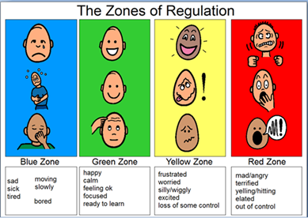  Outdoor Scavenger Hunt  LI: I am learning to look after my mental health.  Enjoy the great outdoors and go on two outdoor scavenger hunts this week. Getting outside and into nature is also very good for your mental health.  Take pictures and upload to good classroom.  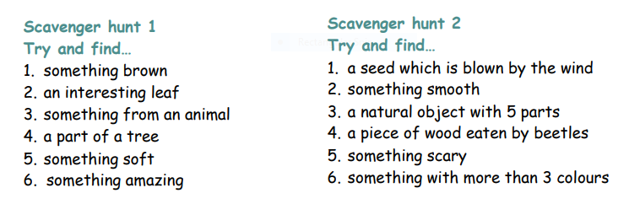 | French  We are learning to conduct simple conversations in another language.  Weekly Lessons  You are able to join Madame Robertson live every Friday at 11am. (Sessions are recorded so you can catch it later at a time that suits. Each session last 15/20 minutes.)  The lesson on Friday 5th March is learning a French song about the sun, moon and Earth.  French lesson  This week we are going to practice vocabulary for Family. “ Ma Famille”  - We will learn the names of some family members.  - We will be able to say how many brothers and sisters we have.  - We will be able to ask someone if they have brothers or sisters.  First of all, please listen to the teaching video in Google Classroom.  There is a copy of the PowerPoint at the end of this document for anyone who is unable to access this.  (The coloured fonts are to help you with the pronunciation, the black fonts show you how to spell the words.)  The video in the link below will also help you to practice a bit more.  French Family – Brothers and sisters  Now have a go at the attached worksheet.  This worksheet should be done orally. You do not have to write anything. It is easier and more fun if you are able to get someone in your family to do it with you.  Instructions.  Call yourselves person A and Person B.  You should only speak French.  - Hello, What is your name?  - My name is…….  A Do you have any brothers or sisters?  B I have………..called  Example (For the first picture)  A. Salut, comment t’appelles-tu?  B. Je m’appelle Lucas.  A As-tu des freres ou des soeurs?  B J’ai une soeur.qui s’appelle Emma.
Family Learning  Thursday 4th March is World Book Day  Everyone in your family could pick a favourite book or story to share. It could be a short story or an extract from a book. You could ask the grown-ups what their favourite books was when they were your age and ask them to tell you about them from memory.  Remember, you could include your extended family by video calling them and reading to them over the phone. Your Grandparents would maybe like to read to you too or tell you about stories that they remember from their childhoods.  You could even make up a book quiz for the whole family!  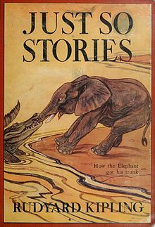  Task 2  The Great P5 World Book Week Bake Off  Take some time this week to design a cake to represent your favourite book, However, you can’t write the title of the book on your cake. If you would like to you can bake the cake and upload a picture to our Google Classroom where we can guess your favourite book. If you are unable to bake a cake, upload a drawn picture of your cake to the classroom.  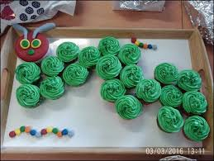 | Learning Across the Curriculum  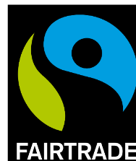  Fairtrade Fortnight  We are learning about the importance of Fair Trade and how we can help to make a difference.  We are learning to carry out research and then use the information to influence others.  This week we are going to find out lots of interesting facts about bananas.  Have a think about what you already know (if anything) about how bananas are grown.  Do you know where they come from?  Do a little research of your own to find out where bananas come from.  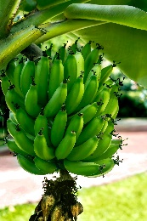  Here is a short video to tell you more about how bananas are grown.  I am sure that you have seen bananas in a supermarket but have you noticed that some of them have Fairtrade stickers on them and if so, do you know what that actually means?  Watch this video clip to find out more.  I now want you to use the information you have learned to help educate others and encourage people to buy Fairtrade bananas.  How you do this, is entirely up to you!  Here are some ideas.  You could:  Prepare a short presentation/give a talk./make a video.  Create a poster or a leaflet  Make up a short advert  Create a slogan.  Make up a quiz  Create a Fact Sheet  Role play – a News report.  Whatever you decide,:  - It must be factually correct.  - It must tell people why they should buy Fairtrade Bananas.  - You must explain how they can identify Fairtrade bananas.  - It must be clear and well presented.  I am looking forward to seeing and hearing about Fairtrade Bananas!  Have fun.  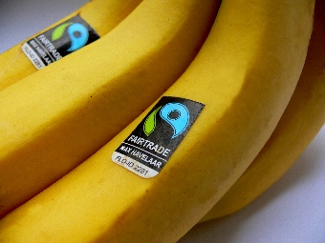  Art  We are learning about the work of a famous artist and are using his work as inspiration to create our own work.  We are recreating own interpretation of everyday objects.  Andy Warhol was a famous American artist. He is best known for a type of art called Pop Art work.  Have a look at the video below which will explain to you what Pop Art is.  What is Pop Art?  Andy Warhol painted everyday objects and then mass produced his work to sell to the public. One of his famous pieces of work is a banana picture!  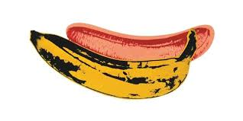  We are going to copy his idea to make out own banana picture.  You will need a sheet of paper and crayons, paints or whatever media you decide to use to colour in your work.  Draw the banana in the background first, then carefully draw the banana which is in the front. (It would be helpful if you have a banana which you can study to help you)  Choose the background colour and do that first.  Then the yellow banana. Remember, a banana can often have black marks on it like the one in the picture.  You could also try doing this where you divide your paper into four equal sections. You do the same drawing in each section but choose a different colour in each section for the banana in the background..  Extension  I found this fun video showing you how to draw a cartoon banana. It looks fun, if you want to have a go!  Draw a carton banana  Complete each activity on the grid – these can be completed in Green Jotter you were given. | Learning Across the Curriculum  Penicuik  Task 1 Listening and Talking  LI: I am learning to present confidently in front of any audience.  During our Google Meet this week (Wednesday and possibly Friday), you will be asked to present to the class virtually. The topic that you will be presenting on is ‘Your Favourite Place in Penicuik’.  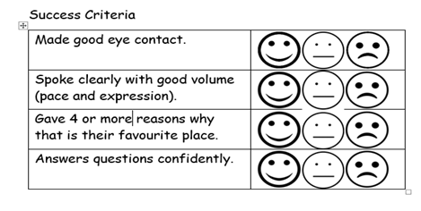  Task 2 – ICT  LI: I have an understanding of the contributions to society ‘by note able Penicuik people.’  There are a number of people who have lived in Penicuik who are famous or at least are well known and it goes to show you, you can do anything if you put your mind to it! Your job this week is to research one of the people on the list and find out as much as you can about them. You can report back in a way of your choice. You might make a poster, write a report or make a ‘news report’ on video in FYI style about the person – you choose! Before picking your person have a look at the list and find out why they are there: did they discover something in science, do something in sport or were they an entrepreneur? Write one sentence about why they are well known then take one of the people on the list and explore them in more depth. Some of the people are from way back and some are right up-to-date.  The people are :  - Agnes Campbell, Lady Roseburn  - Alexander Cowan  - James Finlayson  - Sir James Arnot Hamilton  - Jim Aitken  - Jason Kerr

French

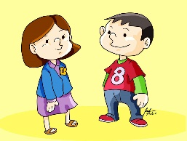
- Tu as des frères ou des sœurs?
- Have you got brothers and sisters?
- Oui, j’ai un frère/deux frères et une sœur/deux sœurs
- Yes, I have a brother/two brothers and a sister/two sisters

- Non, je suis enfant unique
- No, I don’t have a brother or a sister
- (I am an only child)

French Worksheet

Mental Maths – Mild

Mental Maths – Spicy

Mental Maths – Hot
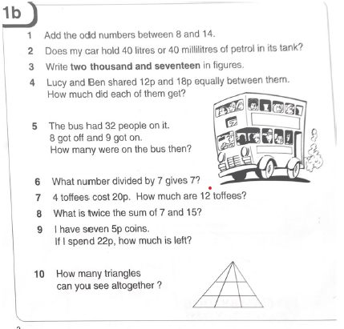
Mental Maths Answers

Maths – Directions – Mild

Maths - Directions – Spicy

Imperative Verbs
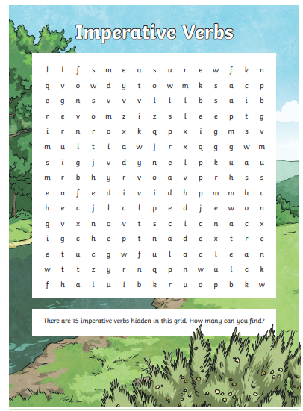
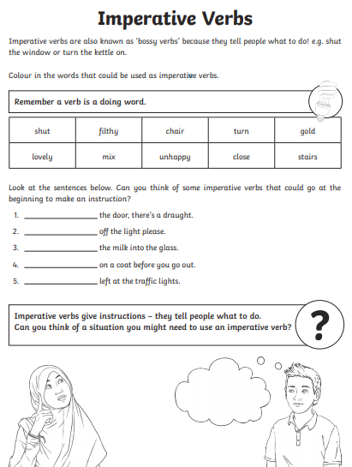

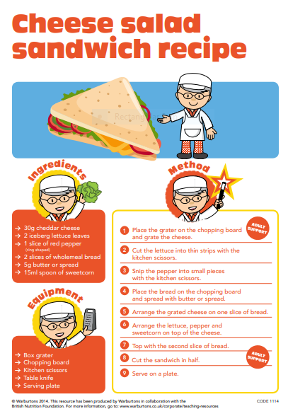
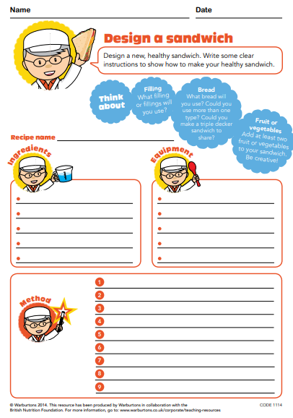
Writing
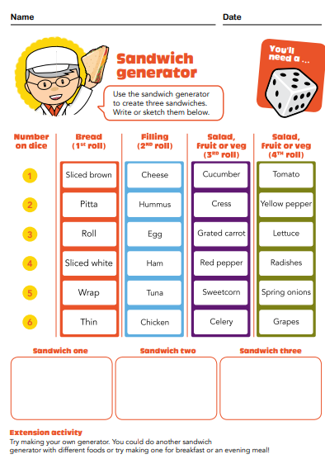
Writing
Learning Across the Curriculum
