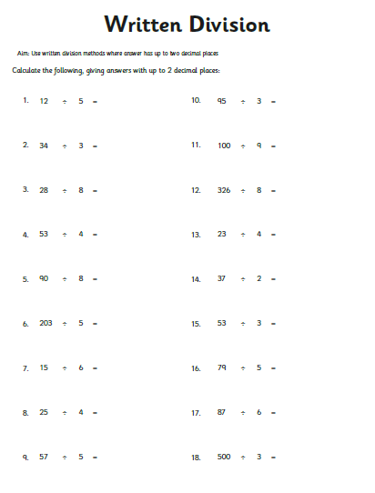
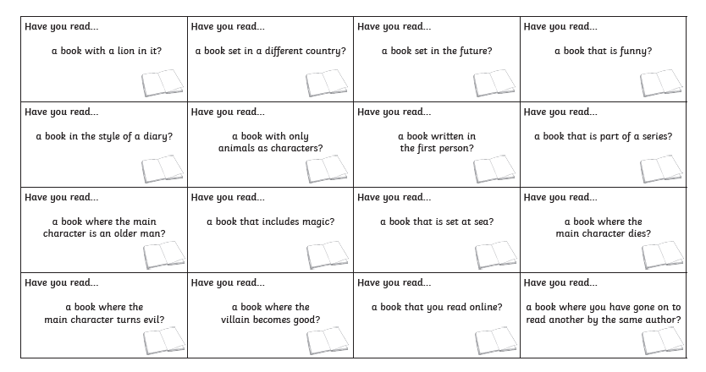
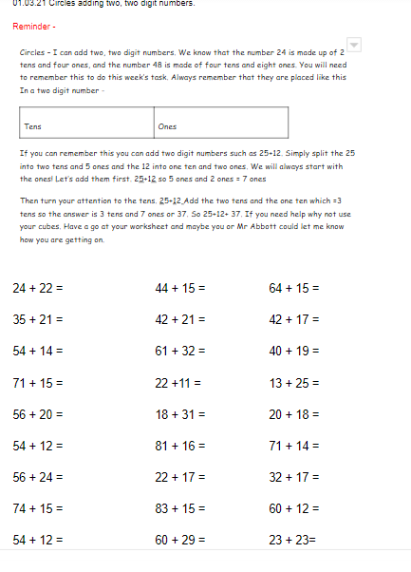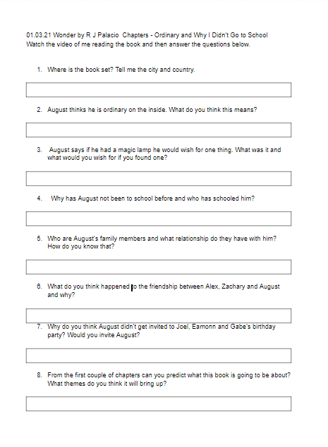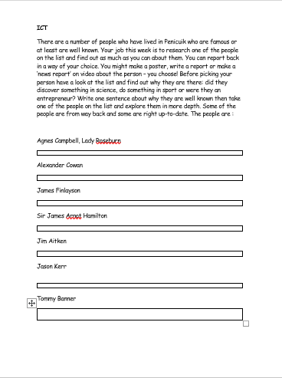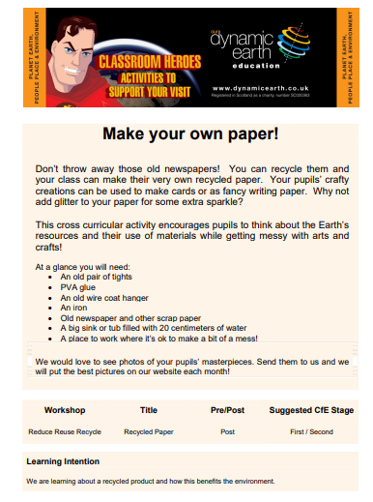
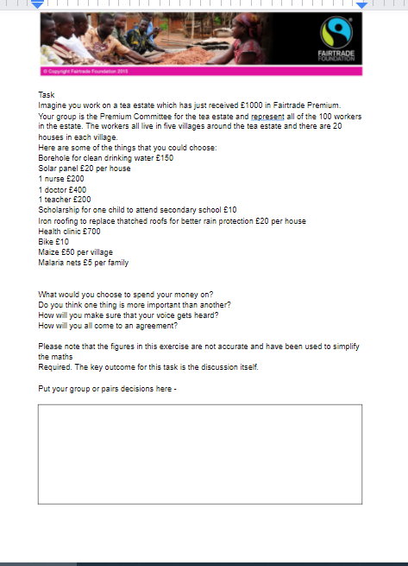
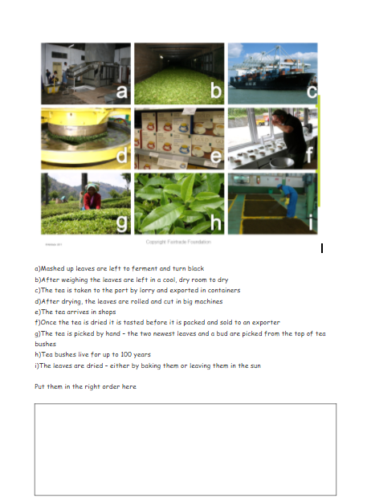
Literacy – Reading  1. Learning intention – I can discuss books I have read with others. It is World Book day on the 4th March so I thought we could have a little competition and there may even be a little prize for those that complete it on our return to school from the lucky bag. Your job is to complete the World Book Day Bingo sheet. Find books you have read that apply to the boxes. The sheet is on the grid or you can do it directly on Google Classroom.  2. Learning intention – I can listen to or read a text and show my understanding.  Listen to me reading the first two chapters of Wonder by R J Palacio on Google Classroom to complete this task.  Once you have played the video answer the questions on the worksheet directly on Google Classroom or complete the answers in your book. The worksheet is attached to this grid.  Please continue to do your own reading as well (15-20 mins a day) and keep going with AR tests to keep your reading skills going. | Literacy – Writing / Grammar  1. Grammar/Writing/Reading Learning intention – I can identify the main features of a report.  This week’s writing task is to write a report but before we do it we are going to recap what a report is by looking at an example. Read the report on Internet safety on Google Classroom and see if you can identify the features of a report including the Heading, subheading, factual information conclusion and third party language.  For a reminder of first, second and third person writing look here - https://www.bbc.co.uk/bitesize/topics/zrqqtfr/articles/zxdhsg8  Using the sheet, highlight the features in the correct colour directly on the worksheet. Use this information to help you with your writing task.  2. Writing – learning intention – I can write a report. Write your own report about Scotland using the features you identified above. You should have three aspects of Scotland in your report and these will form the subheadings. I am happy for you to pick areas that you have looked at in our Scots Weeks such as Scottish landscapes and mountains, Scottish Cities or Scottish music or Scottish food and drink but you can pick three areas that are of interest to you. You will need to do some research first, however do not plagiarise! You will hear more about this word at high school – plagiarising is when you take the work from somewhere else and pass it off as yours i.e. cutting and pasting from elsewhere. Things need to be in your words!  Ensure you write a plan first - a template is on Google Classroom for you to complete. Then include a title, introduction, subheadings, key points for each section and a conclusion. Good luck! | Numeracy  1. Triangles –Learning intention – I can solve equations with letters on both sides. Turn to page 184 of Leckie and Leckie. This week we are going use equations in real life problems and you will need to use all that you have learned in the past few weeks. Complete Exercise 20E and you can then try to do the challenge on 186 and 187 reading the information they give you first.  Rectangles and Squares – I can divide a whole number to two decimal places.  Watch my video first then complete the worksheet online. You may wish to complete the bus stop method in your jotter before putting your answers online.  Circles – learning intention - I can add two, two digit numbers. This week we are going to reinforce what we did last week and complete a different worksheet but on the same skills. Watch my video before completing the worksheet. Try to let me know online how you are getting on or ask Mr Abbott to email me.  2. Triangles, Rectangles and Squares – Learning intention - I can divide. Visit here to play a game to practise your division - https://sct.mathgames.com/skill/1.72-division-with-remainder-with-numbers-up-to-1000  Circles – Learning intention – I can add two digits. Practise your additions skills on this game, visit here - https://sct.mathgames.com/skill/E.56-how-to-make-a-number-values-up-to-100
Maths  1. Triangles, Rectangles, and Squares – Learning intention – I can identify the points on a compass. Watch here for a very good explanation of compass points and the angles involved. You will probably not need to watch it all -  Turns and the 8 point compass - YouTube  The first task is to fill in all eight compass points on the worksheet.  2. The second worksheet is for you to calculate the angles involved in compass points. An angle of 0° corresponds to north, a 90° angle corresponds to east, a 180° angle to south, 270° to west and finally, an angle of 360° (that is, a full circle) corresponds again to north. The directions divide the circle into 4 parts (or quarters). Remember from North  to East  is a 90⁰ turn and measures 90⁰ and so it follows if we were to move from north to north east it would measure half, or 45⁰  1.Cirles – Learning intention – I can recognise properties in a 2 shape  Count the number of sides and corners in a 2D shape.  2. Learning intention – I can recognise right angles in a 2d shape. Angles are where two lines meet. A right angle is where the two lines meet and it looks like the letter L however it can be upside down and back to front. Angles are measured in degrees or ⁰. See if you can identify all the shapes that have right angles. Both tasks are on the same worksheet. | HWB  Learning intention – I can look after my physical and mental health.  1. Hit Up Challenge - I can perform  movement skills in sequence with confidence.  Equipment: Tennis racket and ball. Or adapt and use your hand or any bat/racket/frying pan even! Tennis ball/paper ball/rolled up/socks. Pack of playing cards/20-30 pieces of per in a cup with  the numbers 1-10  Game: on Go, run and pick up the first card return to your racket & ball. Read the number on the card and perform that number of hit ups (hitting the ball up in the air with the racket.)  When you complete your hit ups, stack the card at your base and run to pick up another card. Continue to play until all the cards are gone. If playing on your own see how long it takes you, or play against a partner and see who collects the most cards.  2. Mindfulness colouring in is great for relaxing. Have a go at the colouring in sheet that is on Google Classroom or is on this sheet and have a go somewhere quiet or with some music of your choice on. Remember try not to go over the lines! Please put your efforts on Google Classroom – I know how arty you all are or put it up on Cuiken Twitter! | French  Learning intention – I understand French terms for moon and the planets, birds and can follow a simple experiment in French. Choose 2 from the following activities. They are all available on the lingobox YouTube channel - Lingobox Learning - YouTube  1. On Monday 1st of March tune into the lingo box channel to complete some simple science experiments in French.  2. Take part in a French bird identification challenge on Tuesday 2nd March.  3. On Friday it is a live lesson at 11am, although it can be watched later, where you can learn a song about the orbits of the sun, moon and earth. Enjoy!
Family Learning  1. We know that Penicuik is famous for Paper making and now it is your chance to have a go follow the instructions on how to make paper on Google Classroom or you can see them at the end of the grid. Show off your efforts on Google Classroom or Cuiken Twitter!  2. You know I tell you that not long from now you may need clean and cook for yourself so this week’s challenge is to make some soup! It is a hearty meal and can use up some vegetables that are not quite at their best but the soup can still taste great. You can choose what you would kind to make but you could use the recipe below if you don’t have one yourself.  Ingredients – this serves 4  400g chopped vegetables such as onions, celery and carrots (you can use anything that is lying in the fridge)  - 600g potatoes, cubed  - 2 tbsp or buter oil  - 1400ml stock  - crème fraiche and fresh herbs, to serve if you wish  - Method  STEP 1  Fry the vegetables and potatoes in a pan with the oil/butter for a few minutes until beginning to soften.  STEP 2  Cover with the stock and simmer for 10-15 mins until the veg is tender. Blend until smooth, then season. Serve with a dollop of crème fraiche and some fresh herbs.  If you prefer lumpy soup don’t blend it. I am a blended girl and don’t like the lumps! | Learning Across the Curriculum Fairtrade  Learning intention – I understand how tea gets from plant to shop.  Tea is my favourite hot drink and you know Alex visited Malawi in 2018. The country is very, very poor so this week we are going to look at tea growing and the benefits of Fairtrade to the farmers and communtities.  Tea is mainly grown in tropical and subtropical climates with at least 100cm of rainfall a year. A lot of high quality tea is grown high up as the plants grow more slowly and get more flavour.  China, India, Kenya and Sri Lanka produce three-quarters of the world’s tea. Most of the tea we get in the UK is from Kenya but Malawi is the second biggest African tea producer after Kenya.  The UK takes one third of Malawi’s tea.  1. Have a look at the PowerPoint on Google Classroom up until slide 4 and stop. Your first task is to put the pictures of how tea comes from the plant to shop in the order they happen. There is a worksheet on Google Classroom or on this grid. Do this before revealing the answers on slide 5.  2. The rest of the PowerPoint is about the Satemwa Tea Estate which has been Fairtrade certified since 2007. It employs over 2000 workers and owns its own tea processing factory.  They process 2500 tonnes of tea each year – that’s 800 million cups of tea!  Between 2009 and 2012, the Satemwa Tea Estate received just over £400,000 in Fairtrade Premium.  There is a Premium Committee who are democratically elected who decide how to spend it.  2. Your second task is to work with another class member or two (if possible) and imagine you are on the Premium Committee for a Fairtrade tea estate. The Learning intention – I understand the difference Fairtrade can make to farmers and their communities. You have just received £1000 in Fairtrade Premium and must decide how it is going to be spent.  You and your group represent all of the 100 workers living in five villages around the tea estate. There are 20 houses in each village.  - None of the villages have electricity.  - There is a healthcare clinic in one of the villages with one doctor.  - There is a primary school and a secondary school but not enough teachers.  - A lot of children cannot afford to go to secondary school.  - There is often flooding which damages the houses and during certain times of the year there is little food.  - Three of the villages have access to clean drinking water.  There is no real right or wrong here but do think carefully together about the effects the money will make. Complete the answers on your worksheet.  Only then can you look to see what the people at Satemwa spent theirs on and the effects it had on their community – quite sobering and thought provoking! | Learning Across the Curriculum  1. ICT  Learning intention – I have understanding of the contributions to society by noteable Penicuik people in the past and present.  There are a number of people who have lived in Penicuik who are famous or at least are well known and it goes to show you, you can do anything if you put your mind to it! Your job this week is to research one of the people on the list and find out as much as you can about them. You can report back in a way of your choice. You might make a poster, write a report or make a ‘news report’ on video in FYI style about the person – you choose! Before picking your person have a look at the list and find out why they are there: did they discover something in science, do something in sport or were they an entrepreneur? Write one sentence about why they are well known then take one of the people on the list and explore them in more depth. Some of the people are from way back and some are right up-to-date. The people are :  Agnes Campbell, Lady Roseburn  Alexander Cowan  James Finlayson  Sir James Arnot Hamilton  Jim Aitken  Jason Kerr – very topical over the weekend and an ex- Cuiken school pupil!  Tommy Banner  2. Music  Learning intention – I can use my voice in a variety of ways.  The voice really is a wonderful thing and can do some great things – it is surprising. Watch here - https://www.bbc.co.uk/bitesize/clips/z36c7ty - This is Beardyman who is a beatboxer. Beatboxers imitate the sounds of musical instruments using their mouth, lips and voice to create beat rhythms and melodies. Beatboxing fundamentally began in New York City in conjunction with the birth of the hip-hop subculture on the streets of Harlem. Thanks to the internet, beatboxing has become a global phenomenon enjoyed by millions internationally.  Watch Natural 7 here -  https://www.bbc.co.uk/bitesize/clips/z9fwhyc  Experiement and see what you can do using you mouth, lips and voice. What instruments do you think the voice could replace and why? Write a list of instruments you think the voice could replace. Can you become a human drum kit? Take some lessons on Beatboxing here and become a human drum kit - https://www.youtube.com/watch?v=EAHExoZIgjM Video yourself or send a voice clip only, doing this and submit it with the worksheet – no one except me will see it. Have fun with it.

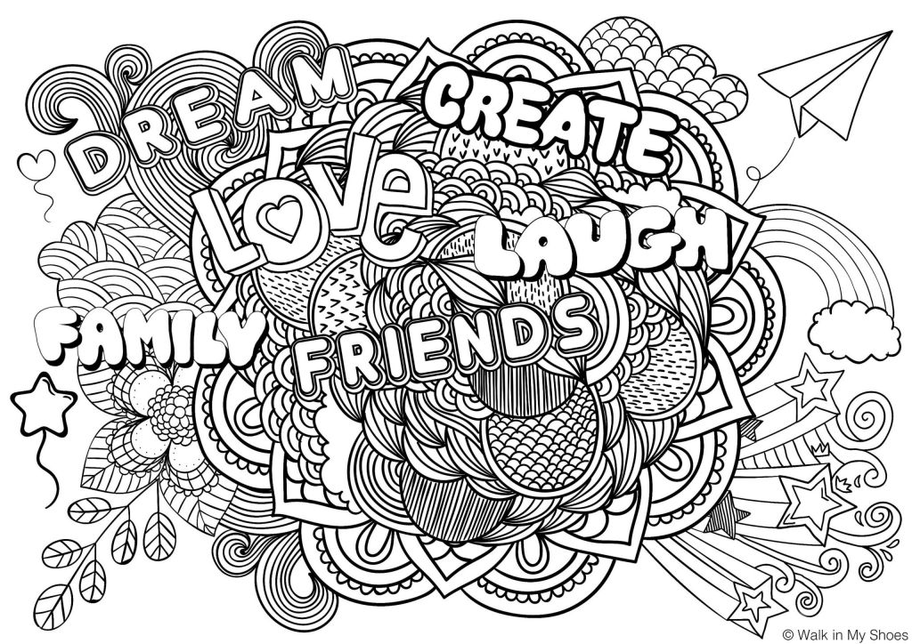
Complete each activity on the grid – these can be completed in Green Jotter you were given.

