Confident Understood Inspired Kind Engaged Nurtured
Be Safe, Be Kind, Aim High

Second Level Home Learning Grid – May 2021
Literacy  Reading – Dictionary Challenge  Using a newspaper, magazine or a book find words that you don’t know the meaning to. Write them down and use a dictionary (online dictionary is fine) to find a definition for them.  You could even challenge a grown up to see if they know the definition to the words you find.  Once you have completed your dictionary challenge use the WordArt Website to create an artistic display of your new found knowledge!  Newsround/FYI  Each day in school we would normally watch Newsround or in some cases SkyNews FYI to expand our knowledge on what is going on in the world.  Using one of the episodes this week (you can choose between Newsround or FYI, I would like you to create 3 questions from what you have seen. These questions should identify what you would like to find out more about or subjects that you feel you did not understand fully.  If you feel comfortable sharing your questions, post them on our Google Stream. It would be fantastic if you could also answer someone else’s question!  Steps:  - Watch an episode of Newsround or FYI.  - Think of at least 3 things you would like to find out more about or did not really understand.  - Create questions to ask someone to help you find the answer.  - Ask a grown up or sibling at home to help answer your question or post it to your classes Google Stream for someone to help you find the answer.  - Remember the answer you provide to someone must be factual (true) so you may have to do some research of your own first!  AR  Aim to read a book for 30 minutes each day. This could be independently, with a member of your household or to a pet or cuddly toy. | Literacy  Grammar  I can use possessive apostrophes in my writing.  An apostrophe can be used to show that one thing belongs to or is connected to something. This is called a possessive apostrophe.  First watch this video to help you better understand possessive apostrophes.  Next choose 2 of the activities from the list below:  - Singular or Plural?  - Andrew’s Apostrophes  - Plural Nouns Challenge  - Missing Apostrophe  Writing  Comic Strip  I can use visual elements to help tell a story.  Design and create a comic strip to re-tell a classic fairytale story. You may add twists into the story but the character names must remain the same as the original.  Inspiration;  Hanzel and Gretel  Cinderella  The Ugly Duckling  Goldilocks and the Three Bears  The Three Little Pigs  Watch this short clip to help you create your comic!  Steps to Success:  - I have at least 4 panels in my comic strip.  - At least 3 of my panels contain speech.  - I have put the first speech box on the left followed by any replies on the right hand side of my panel.  - My images are clear and neat. | Numeracy & Maths  Numeracy  I can use my division fact to the 10th times table.  Remember division is splitting a group/number into equal parts.  Mild - I can divide using the 2, 4 and 8 times table.  Spicy - I can divide using bus stop division within 2 digit numbers.  Watch this video to help you divide 2 digit numbers by 1 using bus stop division.  Hot - I can divide using bus stop division using decimal remainders.  Watch this video to help you use bus stop division with decimal remainders.  I can use my knowledge of place value to round numbers to the nearest 10, 100 and 1000.  Rule of rounding = 4 and below round down.  5 and above round up.  Each day round at least 10 numbers;  Mild- Rounding to the nearest 10 and 100 up to 1,000.  Spicy – Rounding to the nearest 10 and 100 up to 5,000.  Hot – Rounding to the nearest 10, 100 and 1000 up to 10,000.  Sizzling – Rounding any number using knowledge of place value.  You can choose your own numbers, use a random generator or get a member of your household to choose your numbers!  Sumdog – try to access Sumdog daily and play a selection of games to help your skills.  Maths  I can collect various forms of data.  At home I would like you to take part in at least one form of data collection, this could be finding out what your family members favourite food is, the different ages of your family members (including pets) or even what wildlife you see outside your window.  You can find a sample collection below – remember Olive Owl says Be Curious you can think of interesting data to collect!  Challenge –  I can display data using a bar graph.  Use the acronym BLAST to help you remember the key features.  Bars  Labels  Axes  Scale  Title  You can also find example bar graphs here.
HWB  I am learning to experience enjoyment through energetic physical activities of my choosing.  Once a day, take part in 30 minutes of physical exercise this could be:  - Football in the garden  - Just Dance  - GoNoodle  - Joe Wicks  - Yoga  - Tennis practise  - Running up and down the stairs.  I’m learning the importance of mental wellbeing.  Thinking about our Zones of Regulation, each day identify what zone you are in and carry out an activity that will help you get into the green zone.  Once you have identified what helps you in each zone create a toolkit with strategies (actions) that help you when you are in each zone.  For example…  Red Zone – drawing and colouring in, watching my favourite TV show, playing a game I enjoy, cuddling a pet or a soft toy.  Remember that some of your strategies will be the same in different zones. | Learning Across the Curriculum  Music  Watch Tunes with Junes to explore different musical genres.  Can you identify the different genres that Junes talks about?  Choose one of the genres to research further. Can you find…  - A popular artist in that genre.  - A popular song in that genre.  - The instruments that are often featured in that genre.  Challenge  Make your own music!  Use the Nickelodeon Music Maker to create your own songs.  Try different variations to make new songs.  French  I can use my knowledge of French vocabulary when identifying pets.  Practise the names for different pets in French using this Youtube Video. Remember to say the words aloud to practise your pronunciation.  After watching the video create a picture showing the pets you have in your family (if you don’t have any pets you could think of ones that you would like).  Challenge – Using your knowledge of French colours can you add descriptive labels to your pictures?  chat noir = black cat  After you test your knowledge by playing some French games here! | Learning Across the Curriculum  Art  I can create work that shows developing skills.  Paper Crafts  Choose one of the 8 ideas to create, all are easy to make using paper or other common household objects.  6 ideas are featured on this Youtube video.  Create a Village of houses using this tutorial.  Design and make a paper airplane!  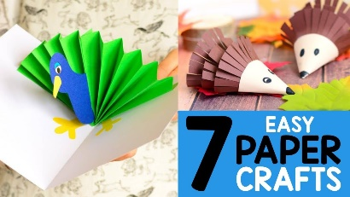  ICT  I am learning to improve my speed and accuracy when typing.  Practise your skills using these typing games!  Learn about some useful keyboard shortcuts that help carry out actions quicker. Keyboard shortcuts are a combination of two or more keys, that, when pressed, perform an action that would usually require using a mouse. Using keyboard shortcuts allow you to command the action to happen without having to take your hands off of the keyboard (to use the mouse).  You could test these using a Word or Google document.  Bold – The action  Red – The keys to hold down at the same time  Control = ctrl on keyboard  Copy - Control + C - This allows you to reproduce a section of text without having to type it each time.  Paste - Control + V - This allows you to insert something that you have already copied to a new application or place  Cut - Control + X - This allows you to "cut out" a selection of text or other data and save it to the clipboard  Undo - Control + Z - This erases the last change done to the document, reverting it to an older state.  Redo - Control + Y - This restores any actions that have been previously undone using an undo  Save - Control + S - This preserves your changes to a document as you work.  Select All - Control + A - This selects (highlights) everything in the current window.

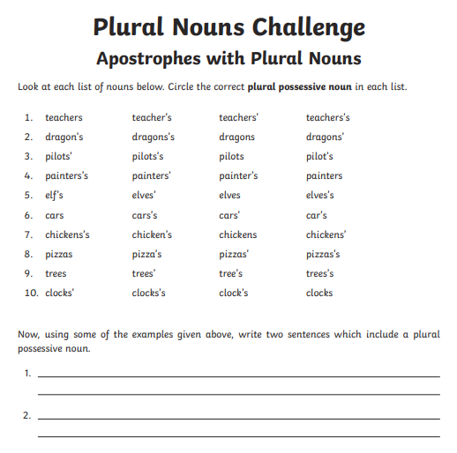
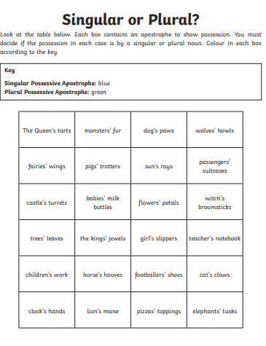

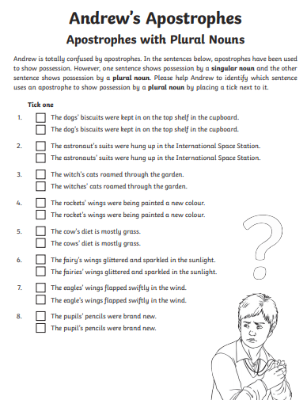
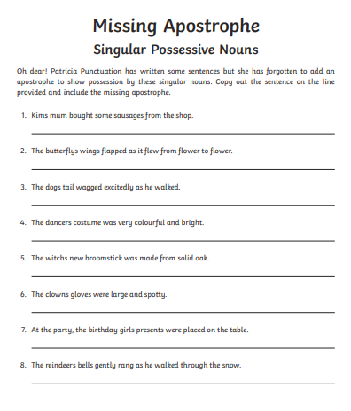
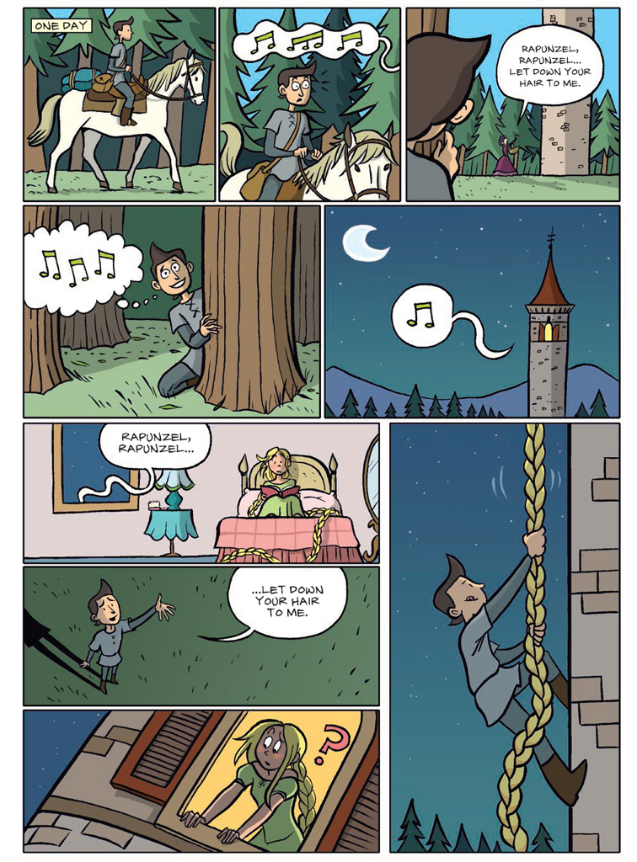
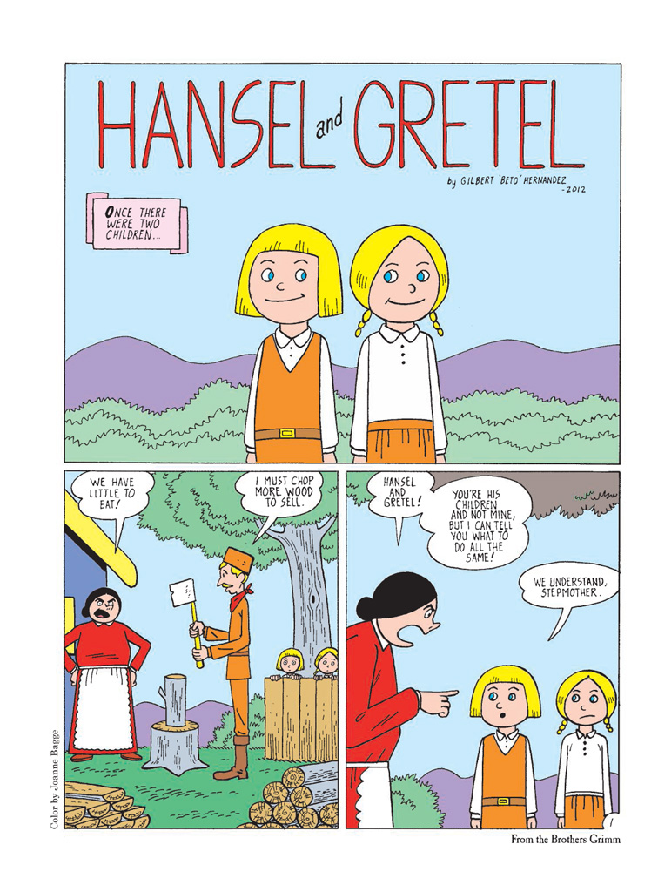
Division
Mild

1. 24 ÷ 2 = b. 24 ÷ 4 = c. 24 ÷ 8 =
2. 40 ÷ 2 = b. 40 ÷ 4 = c. 40 ÷ 8 =
3. 96 ÷ 2 = b. 96 ÷ 4 = c. 96 ÷ 8 =
4. 80 ÷ 2 = b. 80 ÷ 4 = c. 80 ÷ 8 =
5. 32 ÷ 2 = b. 32 ÷ 4 = c. 32 ÷ 8 =
6. 8 ÷ 8 = b. 8 ÷ 4 = c. 8 ÷ 2 =
7. 48 ÷ 8 = b. 48 ÷ 4 = c. 48 ÷ 2 =

Create your own…
8.
9.
10.

Bus Stop Division
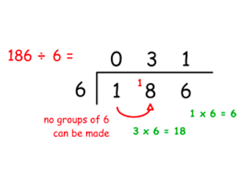
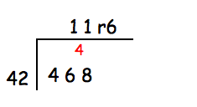
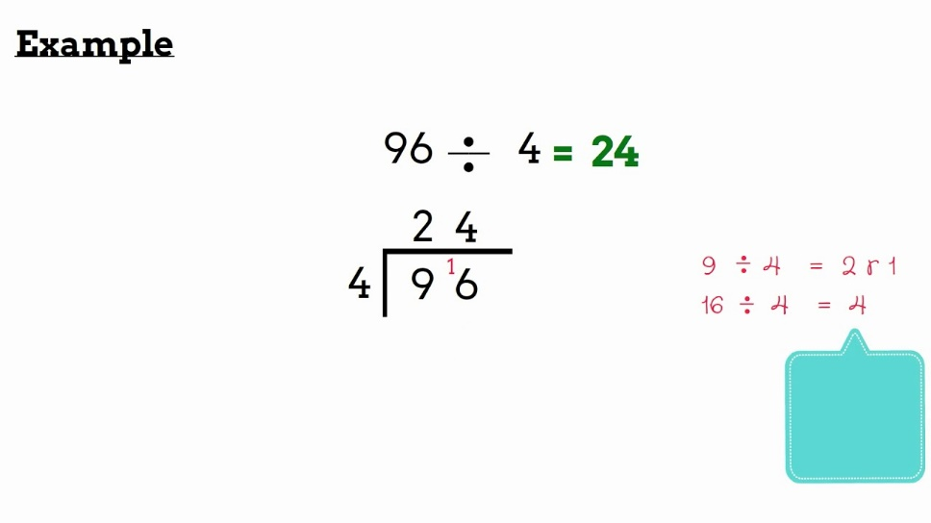
Spicy
Hot
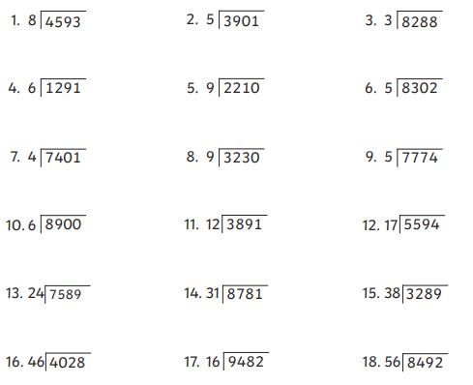

Challenge yourself to create 12 new calculations to complete!

Data Collection
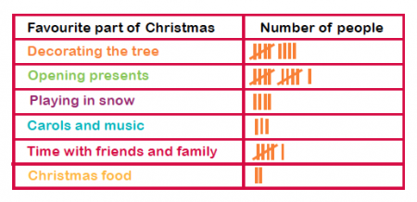

Member of family | Year Born
Mum | 1978
Gran | 1944
Brother | 2006
Cousin | 2010
Me | 2013
Cat | 2018

