Literacy  Practice writing your name, using a pencil. | Literacy  Share a story with a grown up at home.  Talk about your favourite part and draw a detailed picture of this. | Literacy  Practice writing the first 5 RWI sounds  - m, a, s, d, t  - Could you draw picture to that starts with each sound
Numeracy  Practice counting forwards and backwards to 10.  For an extra challenge can you count to 20.  You can practice starting at different numbers.  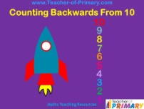 | Numeracy  Can you show numbers to 10 in different ways.  You can use your fingers, you could count out the correct number of objects or you could draw a picture.  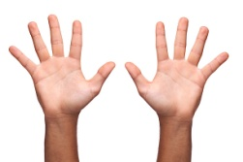 | Maths  Can you draw a square, circle, rectangle and triangle?  Can you go for a shape hunt and find different things in your house that are these shapes?  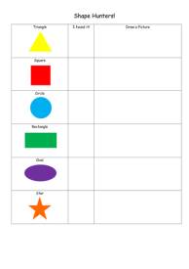
HWB  PE - Search online for a Joe Wicks “5 Minute Move” and complete one every day.  Or, make up your own short fitness routine and teach it to someone at home. | HWB  One of our school rules is to BE KIND, draw a picture of a time where you have been kind.  Talk about what happened and ask an adult to write a sentence underneath.  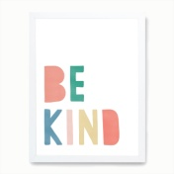 | HWB  Talk with an adult at home about how to be safe when crossing the road.  What different road crossings can you think of and how do you use these?  If you want, search “go safe with Ziggy” on Youtube and learn his road safety song.

