Literacy  Write a diary entry on what you did last week. Remember to start your entry with Dear diary and finish by signing your name. Please include at least two things you have done in detail, at least add two feelings and a detailed picture. I can’t wait to hear what you have all been up to! | Literacy  Read a novel or a story everyday (or get an adult to read aloud to you)  Choose a book you have enjoyed or one of your favourite stories and write a short book review.  Explain briefly what the book is about.  What genre (type of book) is it?  Is it easy to read?  What did you like about it? Describe your favourite part.  Would you recommend it and if so for which age group?  Draw a picture of your favourite part. | Literacy  Create a wordsearch for someone in your house to complete.  Challenge: Create a wordsearch based on what that persons likes, for example football, animals etc.
Numeracy  Practise adding and subtracting.  Mild: Numbers to 20  Medium: Numbers to 30  Hot: Numbers to 40 or beyond!  You can use items around your house such as counters or lego to help you. | Numeracy  Beetle Drive – See below.  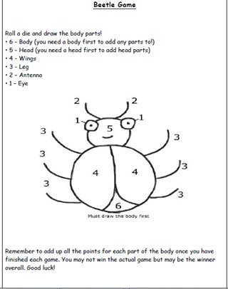 | Maths  Symmetry  An object is symmetrical when it is exactly the same on both sides. Look around your house for things that are symmetrical. It could be the front door or the plate you use for your dinner!  Challenge: Can you draw and colour in a symmetrical picture.
HWB  Having a role model can have a positive impact on your Health and Well Being.  A role model is a person who inspires you and encourages you to be a more positive person.  Write about or draw someone who inspires you and explain why. Make a list of words which describe this person’s character.  You could set it out like the example shown above.  (You can access this at the end of this document)  (If your role model is a famous person, then you could carry out some research to find out more about them. You could then use the information to write a short biography (life story) about them, | HWB  Listening to music can make you feel good and can have a huge impact on your well being.  Certain songs or music can make you feel happy and can cheer you up if you are feeling sad.  Find a song that makes you feel good.  Write the name of the song and the artist.  Draw a picture of how this song makes you feel.  You could set it out like the example below.  (There is a copy of this on the last page) | ICT  Log onto Dance Mat and continue to improve your keyboard skills. Remember to use both hands and only move to the next level when you have mastered the finger positions.  https://www.bbc.co.uk/bitesize/topics/zf2f9j6/articles/z3c6tfr

