Cuiken Primary School

Standards and Quality Report 2022-23
Improvement Plan 2023-24
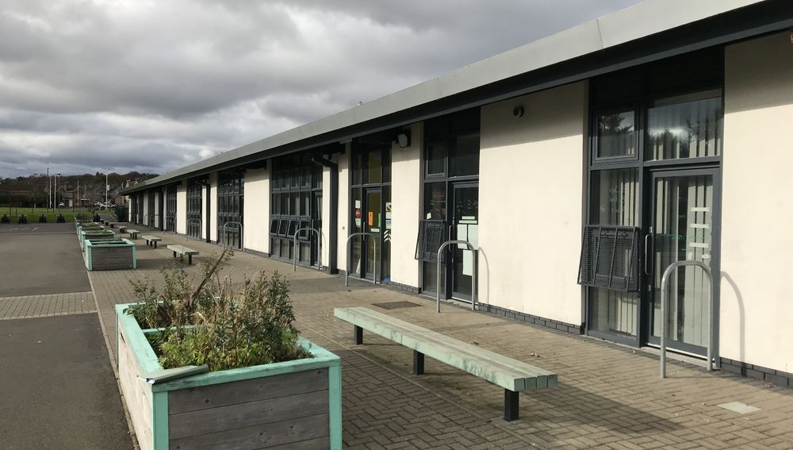

Contents

Section 1: Our context
- School/setting information
- Our Vision, values and aims
- Consultation & communication
Section 2: Standards & quality report 2022-23
- Successes and achievements in session 2022-23
- Capacity for continuous improvement
Section 3: Improvement plan 2023-24
- Raising attainment to ensure that all children and young people in Midlothian achieve outcomes which lead to positive destinations to positive
- Tackling and removing barriers in order to achieve priority 1 All children & young people feel valued & included, and have the same opportunities to succeed
- Improvement drivers
- Associated Schools Group Improvement Plan

Section 4: Data to inform improvement

Section 5: Pupil equity fund plan 2023-24

Section 1: Our context

a) School/setting information

School/setting name: Cuiken PS
School/setting location: Penicuik
Associated School Group: Penicuik
School/setting roll: 231
Link to school data report (see improvement plan section below)
FSM - 19.05%
Pupils living in SIMD 1-2 - 0.43%
Attendance rate 22/23 - 93.57%

Briefly, any other relevant contextual information:
Cuiken Primary School is a non-denominational school situated on Cuiken Terrace in Penicuik and is one of four primary schools associated with Penicuik High School. The catchment area stretches from the immediate vicinity of the school to the countryside to the west of Penicuik including Silverburn and Ninemileburn. The school was built in 2009 and includes an ELC and ASN Provision. For session 2023/24 we will have 9 classes, 1 enhanced class, 1 Complex Needs class and an ELC setting. Our leadership team is made up of an Acting Head Teacher, Acting Depute Head Teacher and Principal Teacher.

b) School vision, values and aims
We asked our Cuiken Family what our current vision and values were in August 2018.
Developing a shared understanding of our vision and values became a priority within our school improvement plan.
With ALL members of the Cuiken Family we explored what we wanted our dream school to sound like, look like and feel like. This was done through assemblies, class circle times, parent consultations, meet the teacher event, twitter, survey monkey and talking to our grown-ups within the playground.
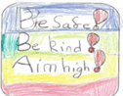
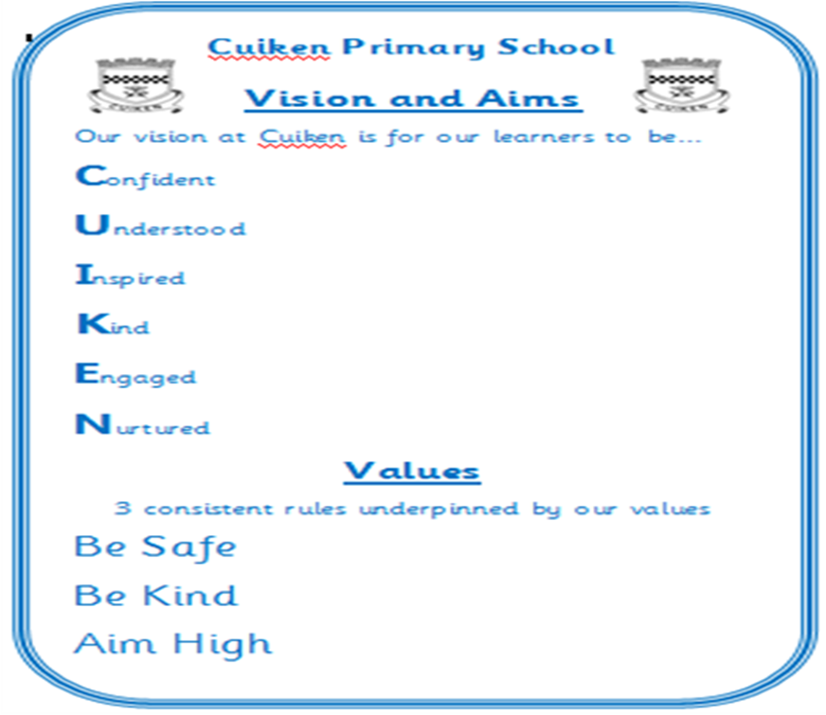
Our final visual was agreed and is embedded in our school culture. Our vision uses each letter from the word ‘Cuiken’ - confident, understood, inspired, kind, engaged and nurtured. Our values are to be kind, be safe and aim high.

c) Consultation & communication

Briefly describe the various consultation activities you have carried out with each stakeholder group below.

This year, we have consulted in the following ways:
With learners:

- Tracking of wellbeing
- CFE data
- Views gathered on how our year has been
- Feedback from assembly tasks
- Informal discussions throughout the year
- Pupil voice groups.

With parents, carers & families:

- Feedback questionnaires
- Cuiken Partnership
- Feedback gathered at parent consultations,
- Informal drop ins and chats in the playground
- At IEP/IP meetings.

With staff:

- Surveys linked to priorities
- PRD/MPM discussions
- Dialogue in CAT sessions
- Staff meetings
- Informal conversations

With others:

- Regular meetings (both formal and informal) with partner agencies including IWBS, EP, MYPAS, ASD outreach, social work and our community police officers.
- Active Schools and Bikeability co-ordinators
- College and university links for students
- P7-S1 transition lead meetings with ASGs
- ASG meetings

Section 2: Standards & quality report 2022-23
This year we worked on the following improvements:

Enhancing Learning,Teaching and Assessment using Digital Technology
- Raising Attainment in Writing and Numeracy
- Equity & Inclusion, including Nurture
- Getting it right for our Cuiken family - Meeting learners needs

Brief summary of how well we did. This should include your PEF plans and associated improvement outcomes.

Improvement outcome we were trying to reach | What happened? | Impact on the improvement outcome. | What next?

Enhancing Learning,Teaching and Assessment using Digital Technology
100% staff using Seesaw to share children’s work and progress. | 100% of teachers use See-Saw a minimum of four times per term to report on learning. | All staff now able to access and use the basic functions of See-Saw  All pupils will be able to share their learning with home, and families will be more aware of what their child is learning.  88% of staff say their confidence has increased in using See-Saw. | 100% of staff will use See-Saw to share class news and events instead of Twitter, following feedback from families.  See-Saw updates will be consistent across the school in all classes.
100% children independently uploading to Seesaw and involved in developing their learner journey. | All children can speak about See-Saw and how to use it.  92% of children feedback that they can upload pictures and comments to See-Saw independently. | 100% of pupils have uploaded work to See-Saw with or without support, over the course of the school session.  Most children are more confident in using their digital device to share learning. | 100% of pupils will upload four curricular areas per term, plus one highlight of the week independently.
Grown ups at home have an increased understanding of what and how their child is doing in school | 79% of parents have signed up for See-Saw | 94% of signed up parents have engaged with See-Saw since its introduction as a reporting tool  61% of those parents feel they have a better understanding of what their child is doing in school.  55% of parents are happy with how we have reported progress in school. | 100% of families are aware of SeeSaw as a reporting tool and accessing it at least once per term.  School has a clear reporting calendar to report including See-Saw with consistent standards.  Highlight to parents all of the ways we report on progress throughout the year.
Staff and pupils confidently using digital devices to enhance learning and teaching. | All classes are using digital devices in class but could be used more effectively. | 100% of staff are using digital devices in class during teaching time and are positive about their introduction.  88% of staff feel they are using digital devices more than they did in previous years.  97% of children state that the digital devices have been a positive addition to school.  77% of parents have a better understanding and an increased confidence in using ipads, Chromebooks and See-Saw. | 100% of staff embed the use of digital devices to enhance learning and teaching.
Teaching staff to use digital devices as a way to increase attainment in literacy for identified pupils. | Introduction of the Read Write toolbar for identified pupils. | Many identified pupils have shown an increased ability in writing through the use of the Read Write toolbar. | 100% of teaching staff confidently use the Read Write toolbar in class with specific pupils.
100% staff aware of progression of digital literacy throughout school through the creation of a school policy. | The majority of staff feel more confident in the use of digital devices in school but no formal policy is yet in place | Consistent use of digital devices for reporting, but less consistency of use in class.  Pupils feel more empowered to use their digital devices, but need a policy to ensure consistency and safety.  88% of staff are not clear on our digital learning policy. | 100% staff aware of progression of digital literacy throughout school through the creation of a school policy.  All pupils are clear on the expectations and rules of digital use in school.
- Raising Attainment in Writing and Numeracy
100% of teaching staff engaging with and using data for literacy and numeracy to influence planning and interventions | All teachers attended 4 data dialogue meetings to discuss progress | 100% of teaching staff stated that their confidence in assessing achievement of a level has increased.  100% of teaching staff stated that data dialogues had a positive impact.  Some stretch aims for literacy and numeracy were exceeded based around actions from the data dialogue meetings. | 100% of teaching staff can confidently discuss their pupil data to inform their judgements.  Staff are able to identify the interventions required in order to improve attainment for identified pupils/groups.
100% of teaching staff use assessment and moderation sessions to feel more confident in their judgments. | Created a responsive assessment and moderation calendar that is more carefully linked in with new planning and needs of teaching staff. | 100% of teaching staff stated that they feel more confident in their judgements | 100% of teaching staff are more confident in their use of high quality assessments.  100% of teaching staff are clear on the expectations of feedback and next steps on pupil work.
100% of teaching staff to engage with professional enquiry that targets raising attainment in literacy. | All staff participated in SEIC Research School professional enquiries. | 100% of staff found the research part of the process useful.  Staff capacity was built through the presenting of findings and new strategies used.  Some identified pupils were able to access learning at a level not previously accessible for them. We found that the administrative side of writing was their barrier, and not imagination, vocabulary or any of the ‘big’ things | Identified staff to lead training on programmes/strategies they used during their enquiry eg. Talking Mats
Increased attainment across the school but specifically P1, P4 and P7 | Input for Literacy and Numeracy for P4 from central team  Termly data dialogues  Specific role of Katrina Cummings (Learning Hub)  Assessment and Moderation sessions across the year (8)  SEAL after school sessions to upskill staff  Specific literacy and numeracy interventions based around data dialogue gaps. | 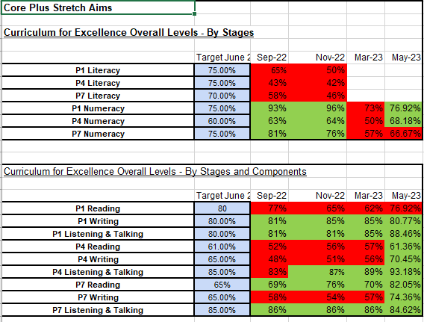 | Develop ambitious stretch aims  Continue with termly data dialogue meetings with specific follow up interventions, where required.  Track pupils who are achieving levels ahead of time to ensure challenge.
- Equity & Inclusion, including Nurture
Continue to develop the role of the enhanced class to target identified pupils in school. | Our team changed and has been consistent since October.  Our class teacher has implemented the use of Boxhall profiles to assess impact.  Each staff member has a bespoke timetable which includes core pupils and wider reaching input. | 100% of staff with pupils accessing the enhanced class said it had a positive impact.  The majority of those teachers (66%) stated that the pupil was accessing their mainstream classroom in a more positive way.  Those identified pupils show progress through Boxhall profiles and ongoing assessments.  SLT are called for far fewer incidents with some identified pupils. | Continue to develop the role of the enhanced class  Enhanced class staff to lead on some staff training around behaviour and nurture.  Have a clear tracking system for pupils who access the enhanced class.
Develop our approach to inclusive classrooms | We had a whole school establishment phase in August to ensure consistency of message and standards.  We reviewed our positive relationship policy as a staff.  We used the expertise of the enhanced class teacher to build capacity in school and to support classes and individuals  We did two separate Team Around the Class meetings to support class teachers and the needs in their classrooms.  We included elements of inclusive classrooms to our quality assurance during sharing classroom visits.  We used assembly to focus on elements of inclusive classrooms.  Sharing classroom practice & learning round data  Differentiation CAT to build staff knowledge of barriers to learning and ways to address them through differentiation | 64% of staff believe their knowledge and practice on the four Rs has improved since August 2022.  We have a 0% exclusion rate for this session.  Minimum ERG referrals as we are able to support our learners in school.  50% of staff have an understanding of Children’s Rights.  83% of children said they have an understanding of Children’s Rights.  53% of staff believe they have a better understanding of nurture principles.  93% of staff do not think we have clear HWB planners linked to our school ethos and values. | Ensure consistency in classrooms across school with a more robust quality assurance process.  Make clear links with Child’s Rights and consistent language in school.  Develop HWB planners linked to our school ethos and vision.
Continue to track the wellbeing of pupils | Pupils were asked to complete a questionnaire twice during the school session (term 2 and 4).Feedback from each was used to inform positive change.  Changes were made to our playground, handover procedures and assemblies in line with feedback. | In May this year, the majority of our learners (133) said they feel safe in school  In May the majority of our learners (130) felt ‘included’ in school | Revisit the wellbeing hearts and embed them in the day to day ethos of the school.  100% of pupils feel safe and included in school
Using play based approaches for our Primary 1 and 2 pupils. | Primary 1 and 2 play based approaches were supported by an EYP, responsive planning and floorbook observations. | Our Primary 1 classes have met all their stretch aims through the use of play based approaches.  100% of staff believe there has been positive improvement in the use of play based approaches since August 2022. | Continue play based approaches with hybrid planning between nursery and school.  Introduction of digital floor books on See-Saw to mirror nursery.
Getting it right for our Cuiken family - Meeting learners needs
ASN tracking and data | Ongoing staff training on supporting our ASN pupils  ASN pupils discussed and tracked at SLT meetings.  TATClass meetings to support teachers to meet class needs.  Talking Mat training for nurture team to ensure all pupil voices are heard regardless of ASN.  Use of safe spaces and dark dens in each atrium.  Inclusion Plans used, referred to regularly and regularly updated in partnership with parents. | 81% of staff feel they are clear on the ASN need of pupils in their class.  80% of staff understand the process of supporting a child with ASN including their pathways and Getting It Right For Our Cuiken Family.  100% of staff feel there has been a positive impact since the introduction of the enhanced class.  66% of staff have indicated that pupils who access the enhanced class are now accessing their mainstream class in a more positive way. | Continue to develop our enhanced class  Develop our new ASN class and ensure their inclusion in the mainstream school.  Ensure our whole Cuiken Family are aware of our ASN procedures and policies.  Highlight and promote diversity and ASN across the school and for all of our Cuiken Family members.
Home Learning | Home learning was issued as designated times in term 1 and 2.  Learning grids are updated and available on our website each term and referred to in term 3 and 4. | 88% of parents have not engaged with home learning.  64% of pupils have not engaged with home learning. | Ensure consistency of home learning across the school.  Communicate clearly with our Cuiken Families regarding expectations around home learning.

PEF IMPACTS

Gap | Intervention | Evaluation | Impact
By June 23, close the gap between FSM v NFSM - LITERACY COMBINED  From: 20%  To: 10%  A decrease of 10% | P4 authority literacy intervention  Clearer literacy planning formats  RWI input  Talk for Writing planning clearer  Two writing moderation sessions in school  Data dialogue discussions X 4 per year | Staff are coming to data dialogues more prepared and knowing their data.  Staff are more confident in their judgements based around CAT sessions and ongoing data dialogue meetings.  P4 authority numeracy intervention helped P4 pupils and build P4 staff confidence.  Talk for Writing CLPL, staff feedback from TfW coordinator for Scotland and ongoing SLT support to implement planning for TfW. | We met our stretch aim as our gap is now -4.71 based on May 23 figures.  100% of staff are clear on literacy planning expectations
By June 23, close the gap between FSM v NFSM - NUMERACY  From: 13.75%  To: 5%  A decrease of 8.75% | Data dialogue discussions X 4 per year  Learning Hub PT released from class to enable interventions for pupils identified through data dialogues  SEAL training for all teaching staff | Staff are coming to data dialogues more prepared and knowing their data.  Staff are more confident in their judgements based around CAT sessions and ongoing data dialogue meetings.  P4 authority numeracy intervention helped P4 pupils and build P4 staff confidence. | We met our stretch aim as our gap is now 2.90% based on May 2023 figures
By June 23, close the gap between FSM v NFSM - READING  From: 18.75%  To: 5%  A decrease of 13.75% | Data dialogue discussions X 4 per year  Data gathered - if children are on track to achieve CFE levels in P1,4 and 7 for reading.  Use of % to measure the gap between FSM v NFSM.  Ongoing RWI interventions across the school supported by LAs and Learning Hub | Staff are coming to data dialogues more prepared and knowing their data.  Staff are more confident in their judgements based around CAT sessions and ongoing data dialogue meetings.  P4 authority numeracy intervention helped P4 pupils and build P4 staff confidence. | We met our stretch aim as our gap is now -0.48% based on May 2023 figures
By June 23, close the gap between FSM v NFSM - WRITING  From: 23.75%  To: 5%  A decrease of 18.75% | Data dialogue discussions X 4 per year  Data gathered - if children are on track to achieve CFE levels in P1,4 and 7 for reading.  Use of % to measure the gap between FSM v NFSM.  Whole school Talk for Writing focus weeks | Staff are coming to data dialogues more prepared and knowing their data.  Staff are more confident in their judgements based around CAT sessions and ongoing data dialogue meetings.  P4 authority numeracy intervention helped P4 pupils and build P4 staff confidence  Talk for Writing CLPL, staff feedback from TfW coordinator for Scotland and ongoing SLT support to implement planning for TfW. | We met our stretch aim as our gap is now 1.69% based on May 2023 figures
By June 23, close the gap between FSM v NFSM - LISTENING AND TALKING  From: 23.75%  To: 5%  A decrease of 18.75% | Data dialogue discussions X 4 per year  Data gathered - if children are on track to achieve CFE levels in P1,4 and 7 for reading.  Use of % to measure the gap between FSM v NFSM.  Whole school Talk for Writing focus weeks (big focus on L&T for the stories) | Staff are coming to data dialogues more prepared and knowing their data.  Staff are more confident in their judgements based around CAT sessions and ongoing data dialogue meetings.  P4 authority numeracy intervention helped P4 pupils and build P4 staff confidence  Talk for Writing CLPL, staff feedback from TfW coordinator for Scotland and ongoing SLT support to implement planning for TfW. | We met our stretch aim as our gap is now -0.85% based on May 2023 figures
By June 23, improve attendance for all  From: 94.25%  To: 95%  Improvement of: 0.75% | Admin staff gather attendance data from Seemis weekly.  HT to analyse data weekly, action where required and monitor impact.  Data also discussed and analysed at fortnightly meeting learners needs SLT meetings.  Free breakfast club to encourage coming to school earlier and being ready to learn (Mon-Thur) | Over half of our pupils have accessed the breakfast club at some point over this session.  Contact from home regarding absences has increased (previously no contact to advise why).  Staff are more aware and look for patterns in attendance and sharing concerns on Wellbeing Concern forms. | Our attendance rate is currently 93.57%.  There was a notable increase in term time holidays due to the expense of school holiday time. These were not authorised.  There were still reports of Covid absences.
By June 23, improve exclusion rates for all  From: 12.61  To: 0  Improvement of: 12.61 | Exclusion data gathered from Seemis weekly.  More use of the enhanced class  Use of yoga for identified pupils.  Input from Pauline Lawson (EmotionALL) about regulation and understanding emotions. | 36 children to access yoga.  30 children to identify increased safety in school following yoga sessions. | We met our stretch aim as our exclusion is 0%.
All children have access to a school trip and P6s access school camp | All P6 (except 1) attended school camp  All classes/pupils attended an end of year trip paid for by PEF. | P6 feedback on camp was unanimously positive  Every class had a trip or participated in a ‘special’ activity in the Summer term  A better balance of the cost of the school day | Every child in the school accessed a trip or activity for free.

Our current strengths include
Insert your school’s/ setting’s main strengths as identified in this year’s self-evaluation activity. Please use evaluative language.
Strength | How do we know?
E.g. Learning, teaching & assessment. | E.g. Features of effective LTA were observed in almost all (90%) of classroom observations 2022-23.
Learning Teaching and Assessment:  Teaching staff are now clear on what a quality lesson looks like  In all classes, there are high levels of engagement in Talk for Writing and other curricular areas.  Most learners are motivated to learn and talk confidently about themselves as learners. | 100% of staff said they were aware of our Learning and Teaching expectations in the May inservice questionnaire data  Out of the five classes visited, areas of high quality learning and teaching was observed in three during classroom observations during our 2.3 classroom visits.  High quality learning and teaching was also observed in three of the other classes during SLT classroom observations in the same term.  Sue Cove (TfW) observed lessons throughout the school and had very positive feedback about the learning and teaching, but more specifically about the engagement of the pupils.  During learning rounds and classroom visits, the same engagement was also noted.  We regularly have pupil voice meetings and our children speak confidently about their learning.  During our 2.3 visit our pupils’ ability to talk about their learning was noted as a strength.
Reporting:  All ELC and teaching staff are reporting on pupil progress more regularly throughout the year.  Most school learners contribute to the reporting throughout the year.  We are reaching more families, more regularly with progress updates with our new reporting formats. | 100% of ELC and school staff use See-Saw as a reporting tool.  All ELC and teaching staff are using See-Saw to report on all core curricular areas each term, and another curricular area each term.
Curriculum Planning:  All teaching staff contributed to the year-long process of updating our planning formats and templates.  Previous gaps highlighted in planning, have now reduced and in some cases gone altogether. | 100% of staff are now clear of our planning expectations and formats.  100% of staff are using the new Midlothian numeracy and literacy planners.  All staff have provided plans that matched agreed expectations for IDL, weekly and annual planning through this session.  80% of class teachers provided literacy planning inline with agreed expectations, with the other 20% only needed small changes.  All planning expectations and formats have been agreed by all staff to continue into next session
Raising Attainment and Achievement:  Termly data dialogues where teachers come prepared with their data and ideas of interventions required.  Learning Hub interventions are driven by the data from the data dialogues for targeted individuals and groups.  Learning assistant knowledge and abilities to lead interventions  P4 literacy and numeracy authority interventions.  Assessment and moderation sessions that match the needs of the staff and school. | We met all of our stretch aims with the exception of P1 reading and P7 numeracy. However we have a clear idea of how to address both next session.  100% of staff said that data dialogue meetings and assessment and moderation sessions have developed their confidence in assessing achievement of a level.  Our learning assistants were noted as a strength during our 2.3 visit due to their knowledge and professionalism.  P4 staff have engaged positively with the interventions and followed through in a consistent way.  Our P4 attainment has increased across the year and we have met our stretch aims.
Wellbeing, equity and inclusion  Many of our most challenging pupils and those with ASN are managing to access learning in an environment that works for them.  Some of our ASN pupils have made steady progress through access to both our enhanced class and their ‘home’ class.  Children feel safer in our playground and there has been a reduction in ongoing negative behaviours. | 100% of staff believe that our enhanced class has been beneficial in supporting ASN pupils and those who display challenging behaviours.  Our enhanced class now supports 6 core pupils and has a flexible timetable to support further pupils and small groups throughout the year. The core number will increase for the next session.
Our areas for development, over the next 4 years, include
You may wish to use this table to give a high level indication of the phasing of the Midlothian Service Improvement Plan priorities in your school/setting.
2023-24 | 2024-25 | 2025-26 | 2026-27
Planning  - Embed the use of the Midlothian Literacy and Numeracy Progression planners | - Review and adapt as required, all progressions planners including the Midlothian Literacy and Numeracy Progression planners to ensure impact on attainment | - Review and adapt the progression planners that support our current ‘bundling’. | - Ensure our curriculum rationale is fully embedded and still reflects our specific context, encompassing all four capacities and all curricular areas.
Inclusion and ASN  - Develop tracking and monitoring of pupils needs and interventions across the school, including the enhanced class | - All pupils and families are aware of our ASN and inclusion policy and how it is enacted in school | - All staff feel confident in their ability to manage, track and plan for ASN in their classrooms effectively, and in line with our school policy | - Whole school and ELC that promotes diversity and provides environments that are inclusive for all.
Rights Respecting Schools  - Creating a shared understanding of Rights Respecting Schools and what it looks like in Cuiken eg. pupil voice in planning | - Address any gaps in our approach to Rights Respecting Schools and embed the rights language through reporting. | - Ensure pupil voice is apparent through SLT decision making and community links. | - Pupil voice fully embedded through planning, reporting, learning and teaching, using rights based language.
Digital Technology  - Create a digital learning policy that includes reporting, home learning and supporting learners with ASN. | - Create/adapt a digital progression for use from ELC to P7 | - Digital literacy is evident in all learning and teaching, and staff are confident in its use. | - Digital devices are full embedded through learning and teaching and all pupils, staff and families are confident in our policy
Learning and Teaching  - Core standards in classrooms such as LI & SC, differentiation are evident in all planning, learning and teaching | - Our play based approach is fully embedded in P1-3 with a robust planning and monitoring/tracking process to support it | - Teaching staff are proactive in their approaches to pedagogy, and learning is more personalised to suit pupil needs. | - High quality learning and teaching is evident in all classes, and pupils know exactly where they are in their learning.
Learning for Sustainability  - Have a shared and agreed target for Cuiken in learning for Sustainability | - Have an agreed action plan that correlates with the timeframes on Scotland’s Learning for Sustainability | - Pupils can speak about Learning for Sustainability in Cuiken and what that means for them and the wider community | - Learning for Sustainability is fully embedded in our planning and learning and teaching, with clear goals being met year on year.

Successes and achievements in 2022-23

Our wider achievements and successes this year include
Insert brief summary of your school/setting’s major achievements.

Enhancing Learning, Teaching and Assessment
- All class teachers successfully completed Research Schools through SEIC, completing a practitioner enquiry which directly impacting pupils’ literacy in Cuiken
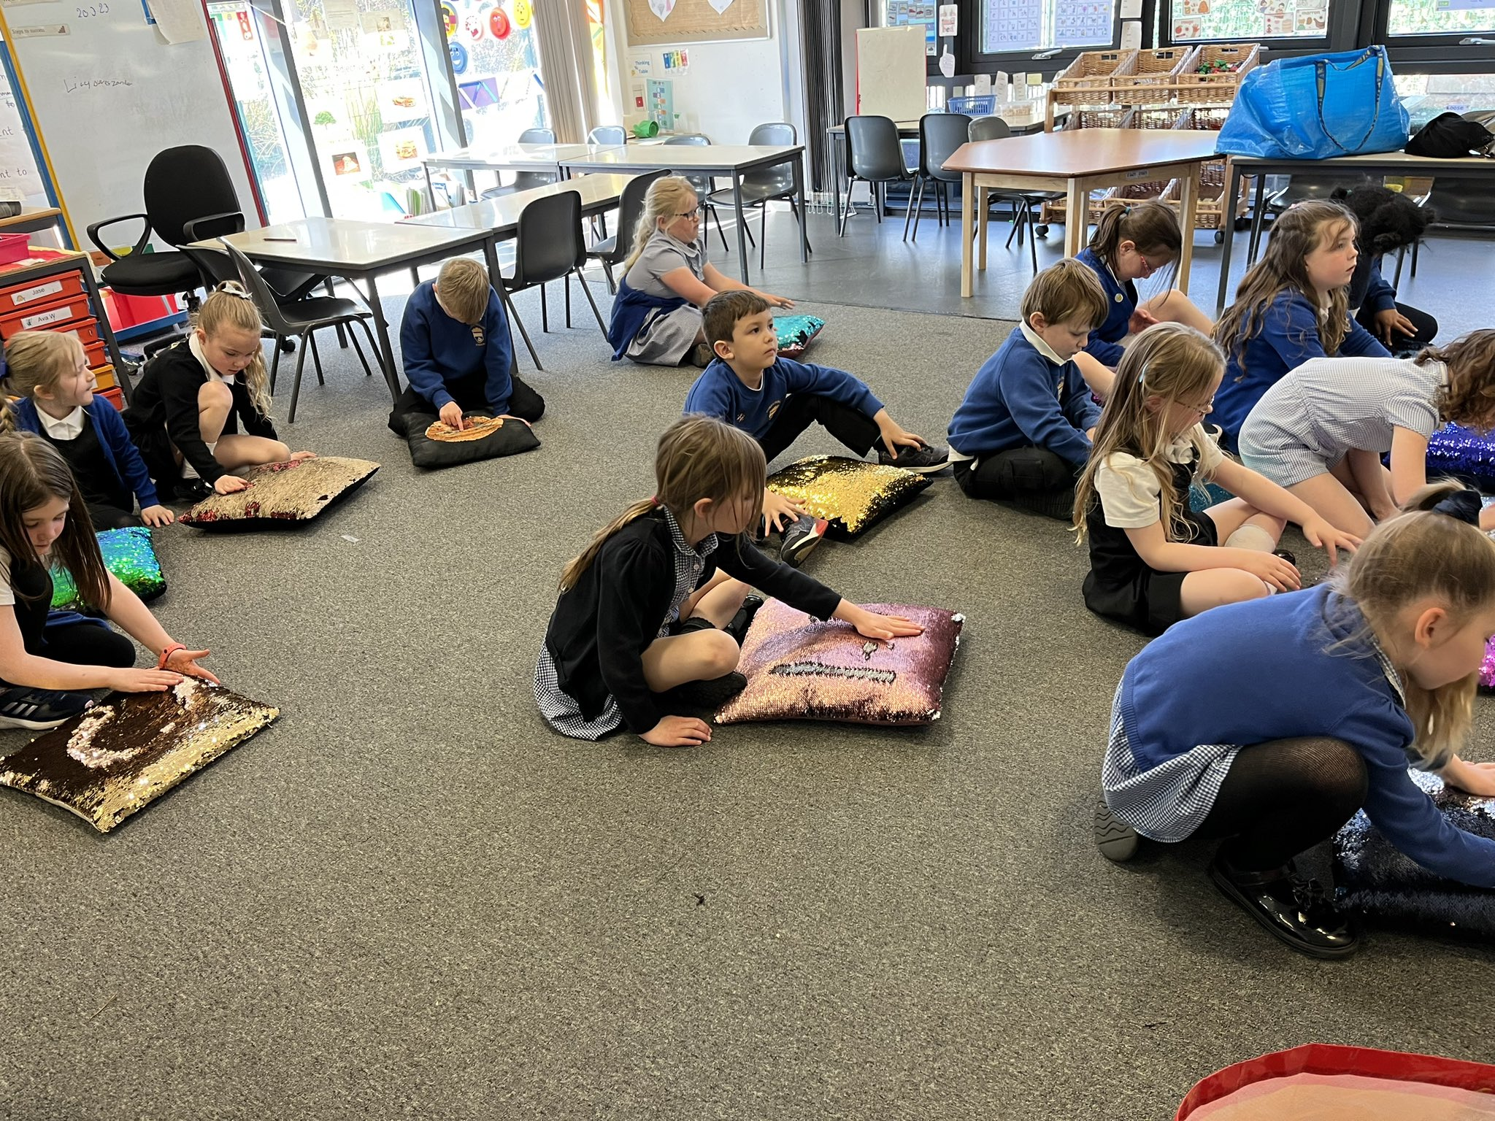
- Every class teacher ran a lunch time or after school club which increased pupil confidence and ability in things ranging from drama, singing, digital and art.
- School sports day had the highest turn out of Cuiken families since before Covid
- Four classes across the school participated in drumming workshops resulting a performance
- Generation Science
- Nursery stay and play sessions and access to Cuiken Cafe
- Bikeability for P6
- Whole school Scot’s author and storyteller visits
- Pauline Lawson from EmotionALL working with all classes about regulation and own wellbeing
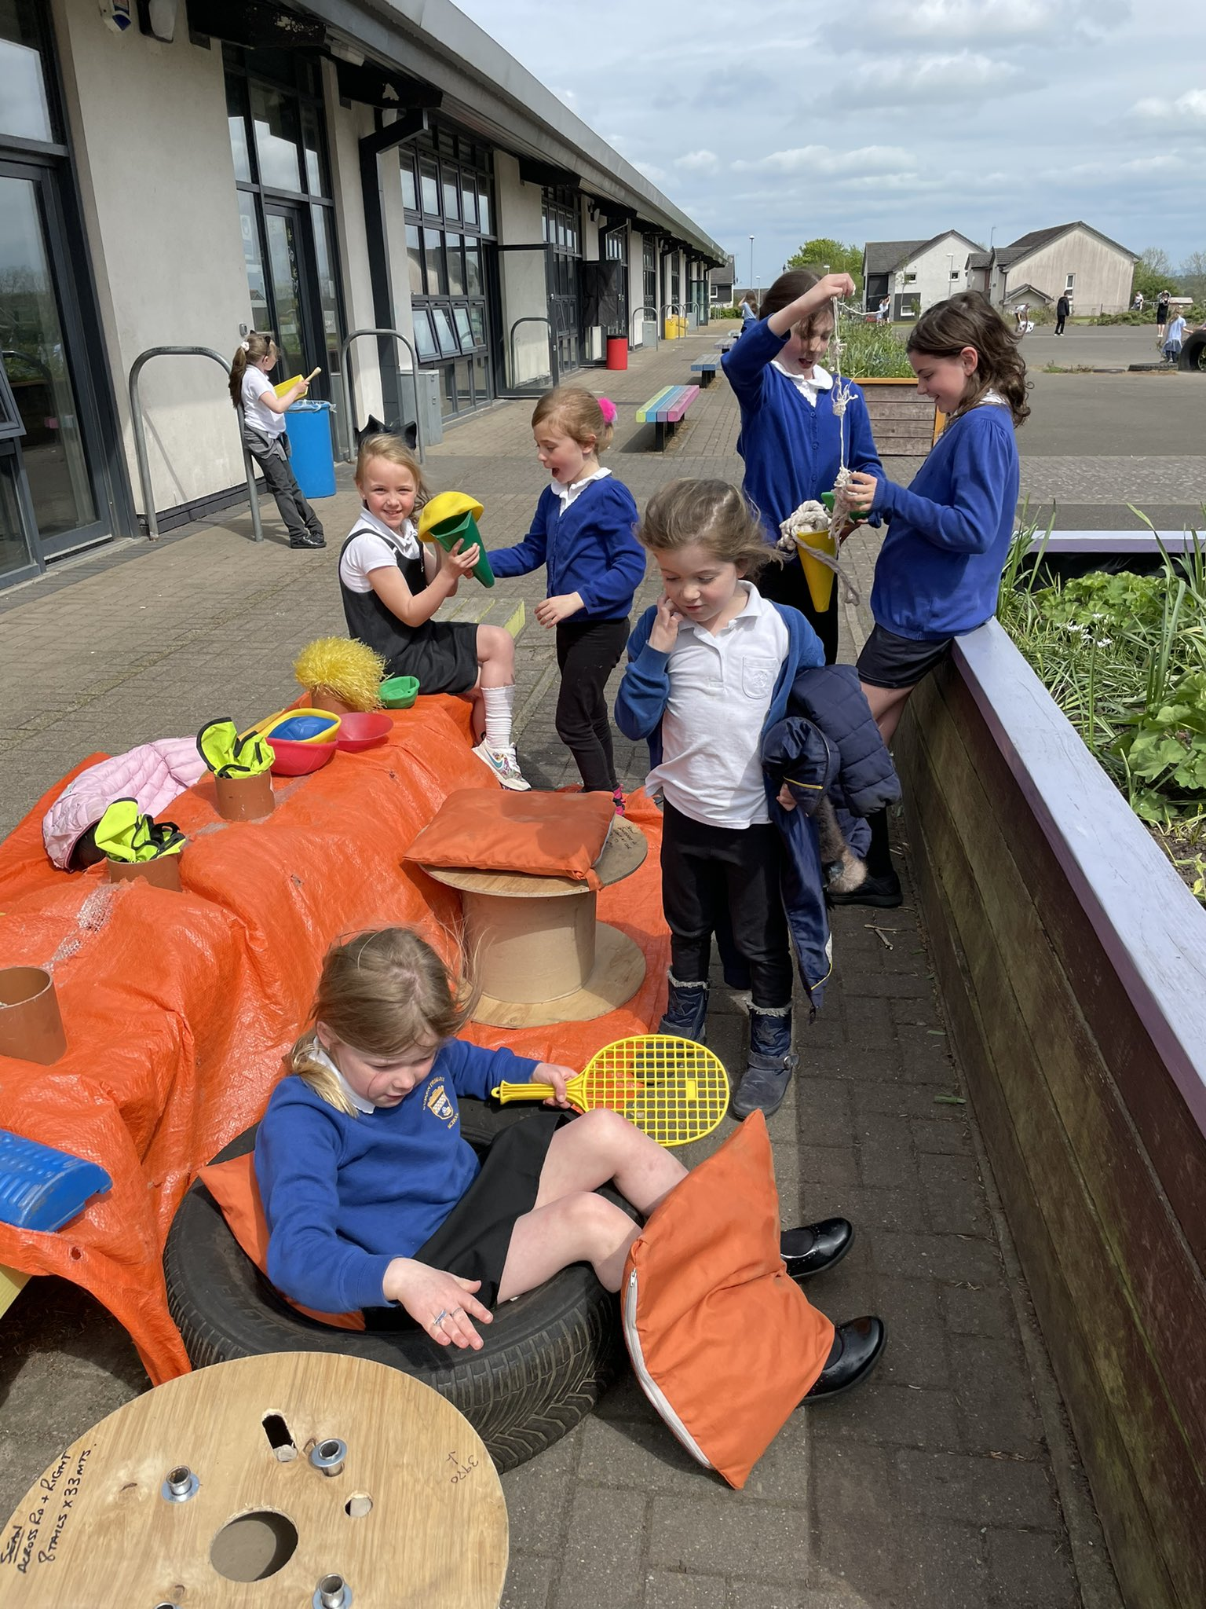
- Health and Wellbeing Fortnight included activities such as smoothie bike, line dancing, keep fit classes and cricket
- P4 interventions for literacy and numeracy
- P7-S1 transition groups in school and in Penicuik High School
- Loose parts play in the playground
Supports for families, groups and individuals
- Yoga classes for identified pupils
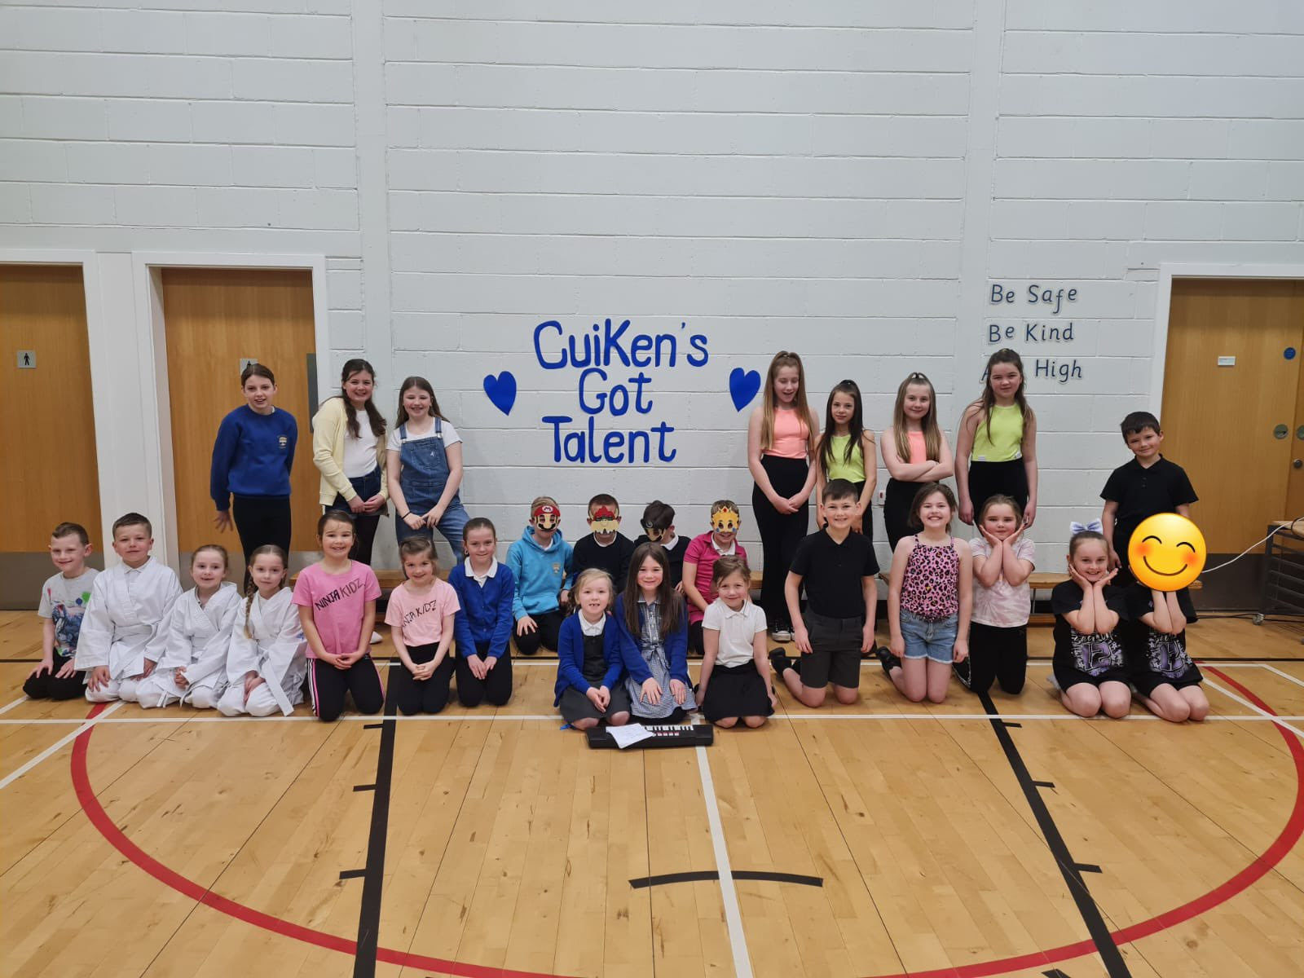
- School counsellor input for identified pupils
- Zoologist work with identified pupil and then his class
- Flexible/bespoke timetable for identified pupils
- Parent drop in with Pauline Lawson and SLT
- Book sale and book swap for all children and families prior to Christmas
- Thrift shop and new uniforms available for free for families
Wider achievement in the community
- P5 achieved beginner certificates for skiing
- P6 successfully completed school camp at Dalguise
- Our three finalists from Cuiken’s Got Talent were awarded 1st, 2nd and 3rd place during Hunter & Lass 2023
- Hunter & Lass assembly
- Continued link with Rosslyn Chapel, created new link with Papermaking Museum
- School sports day had the highest turn out of Cuiken families since before Covid
- ELC continued their intergenerational link with the local day centre
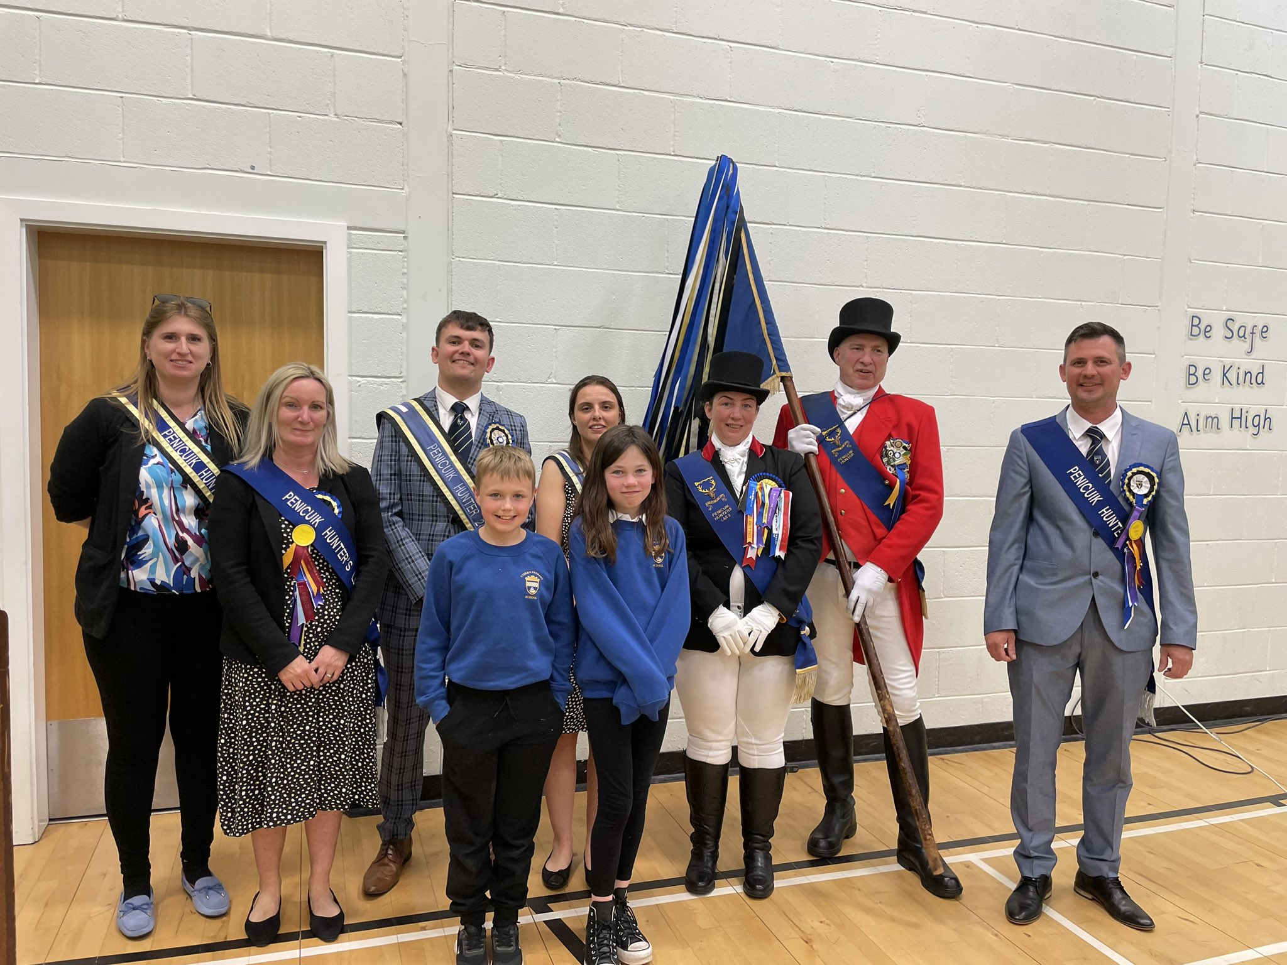
- Cuiken Partnership meetings and fundraising events eg. Halloween disco and Christmas Fair
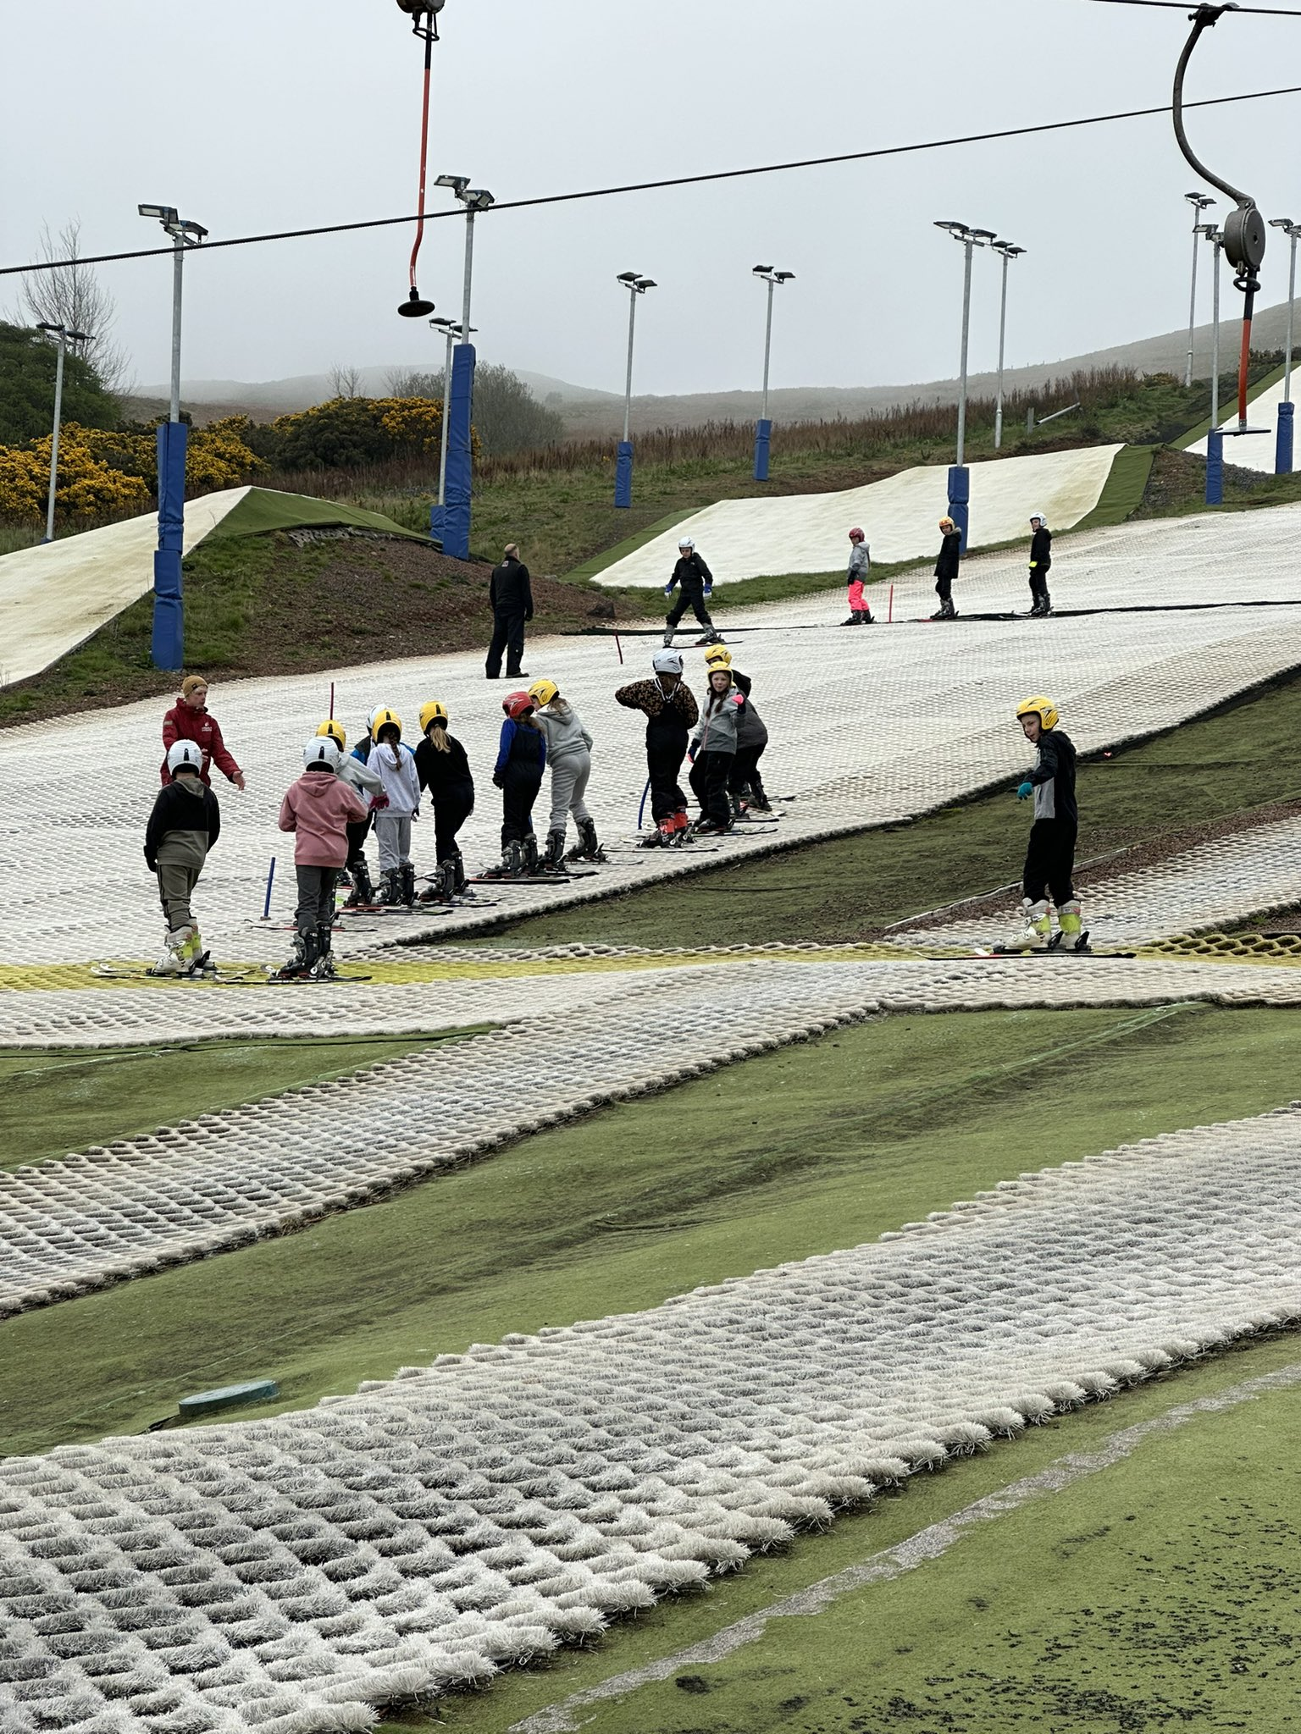
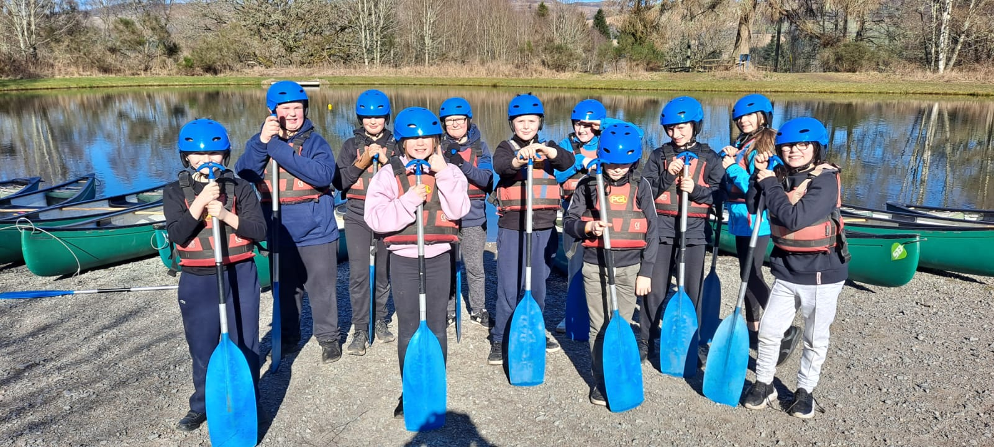

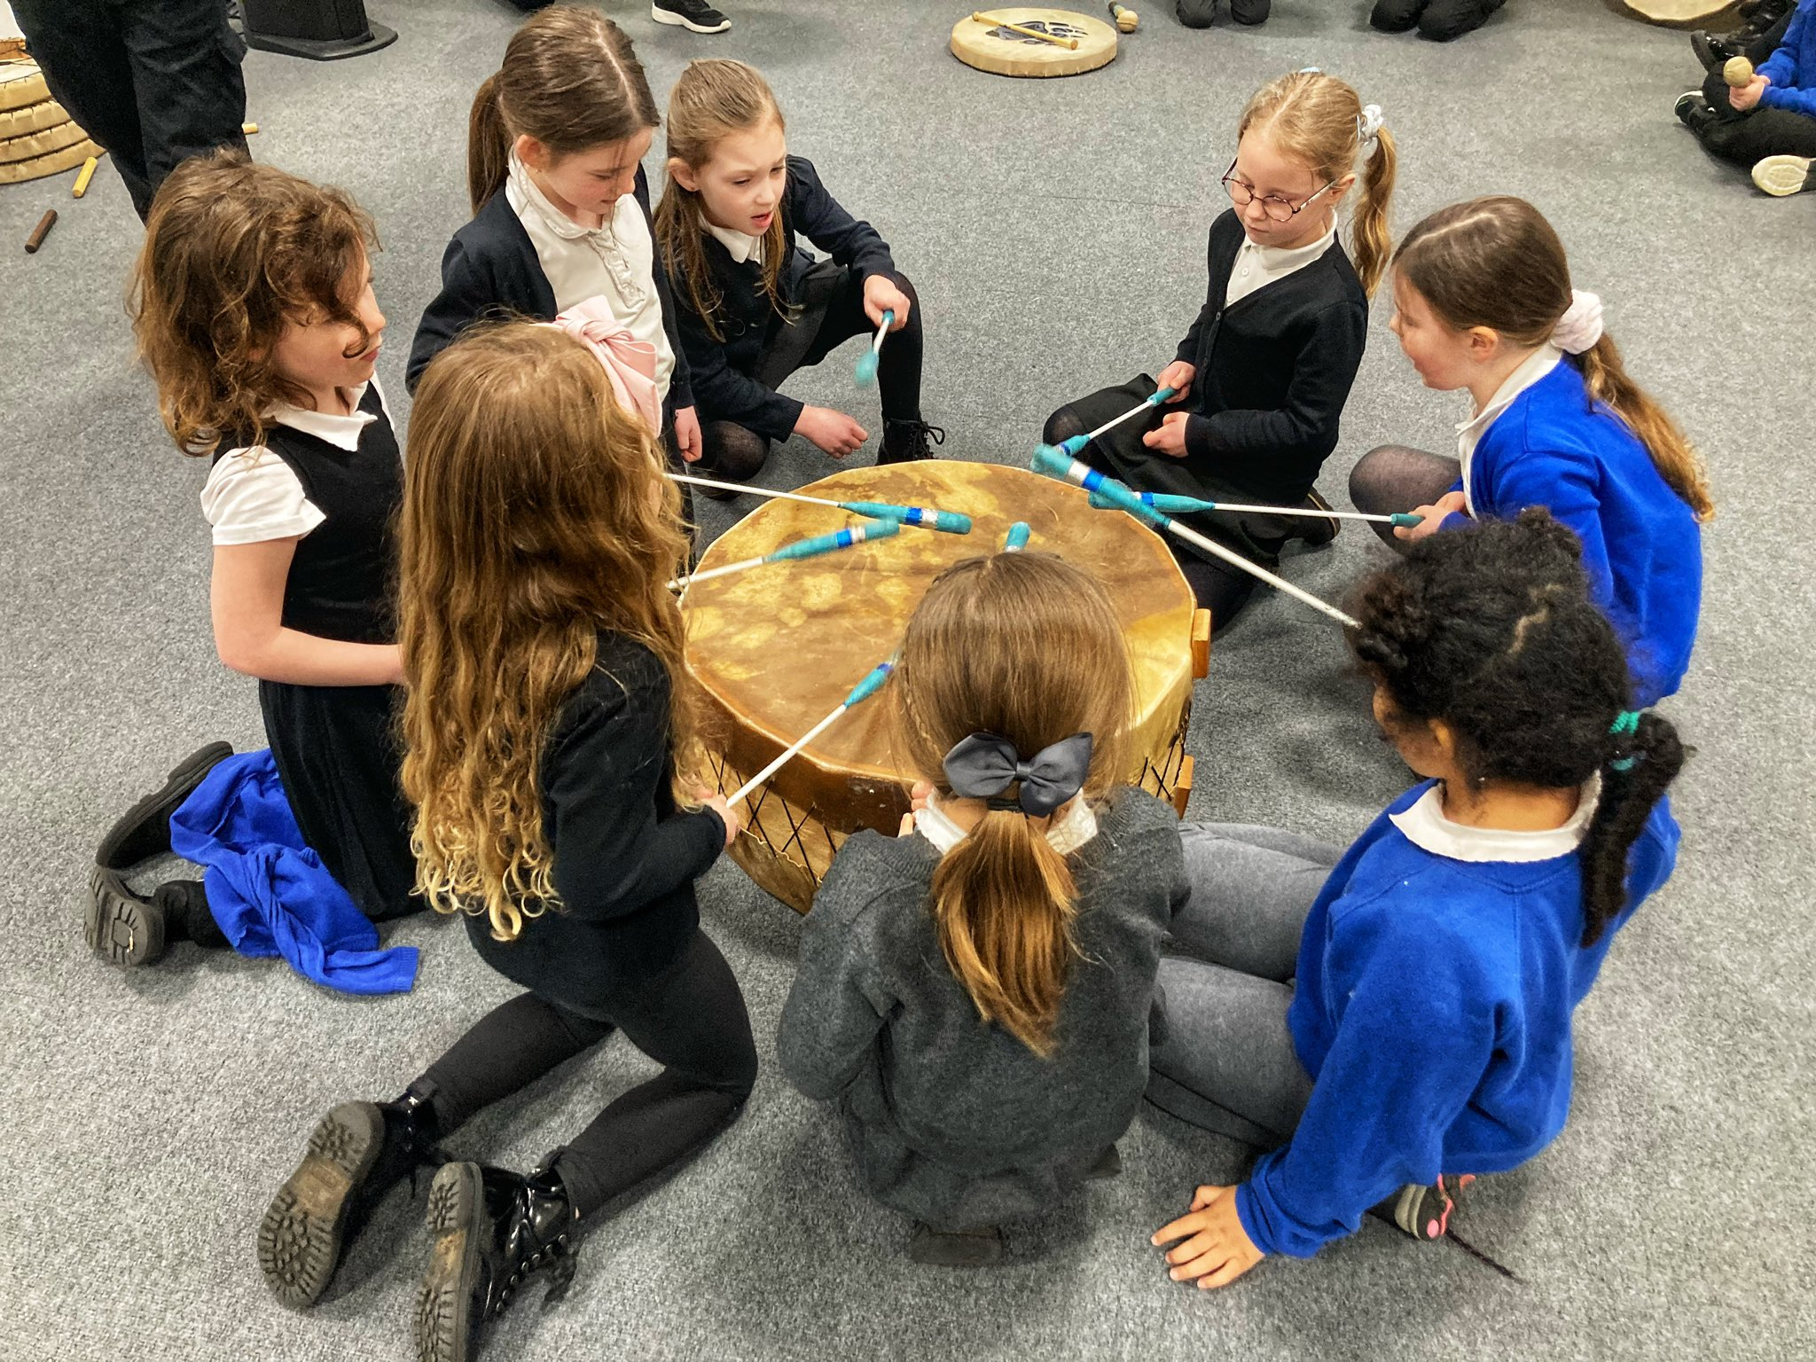
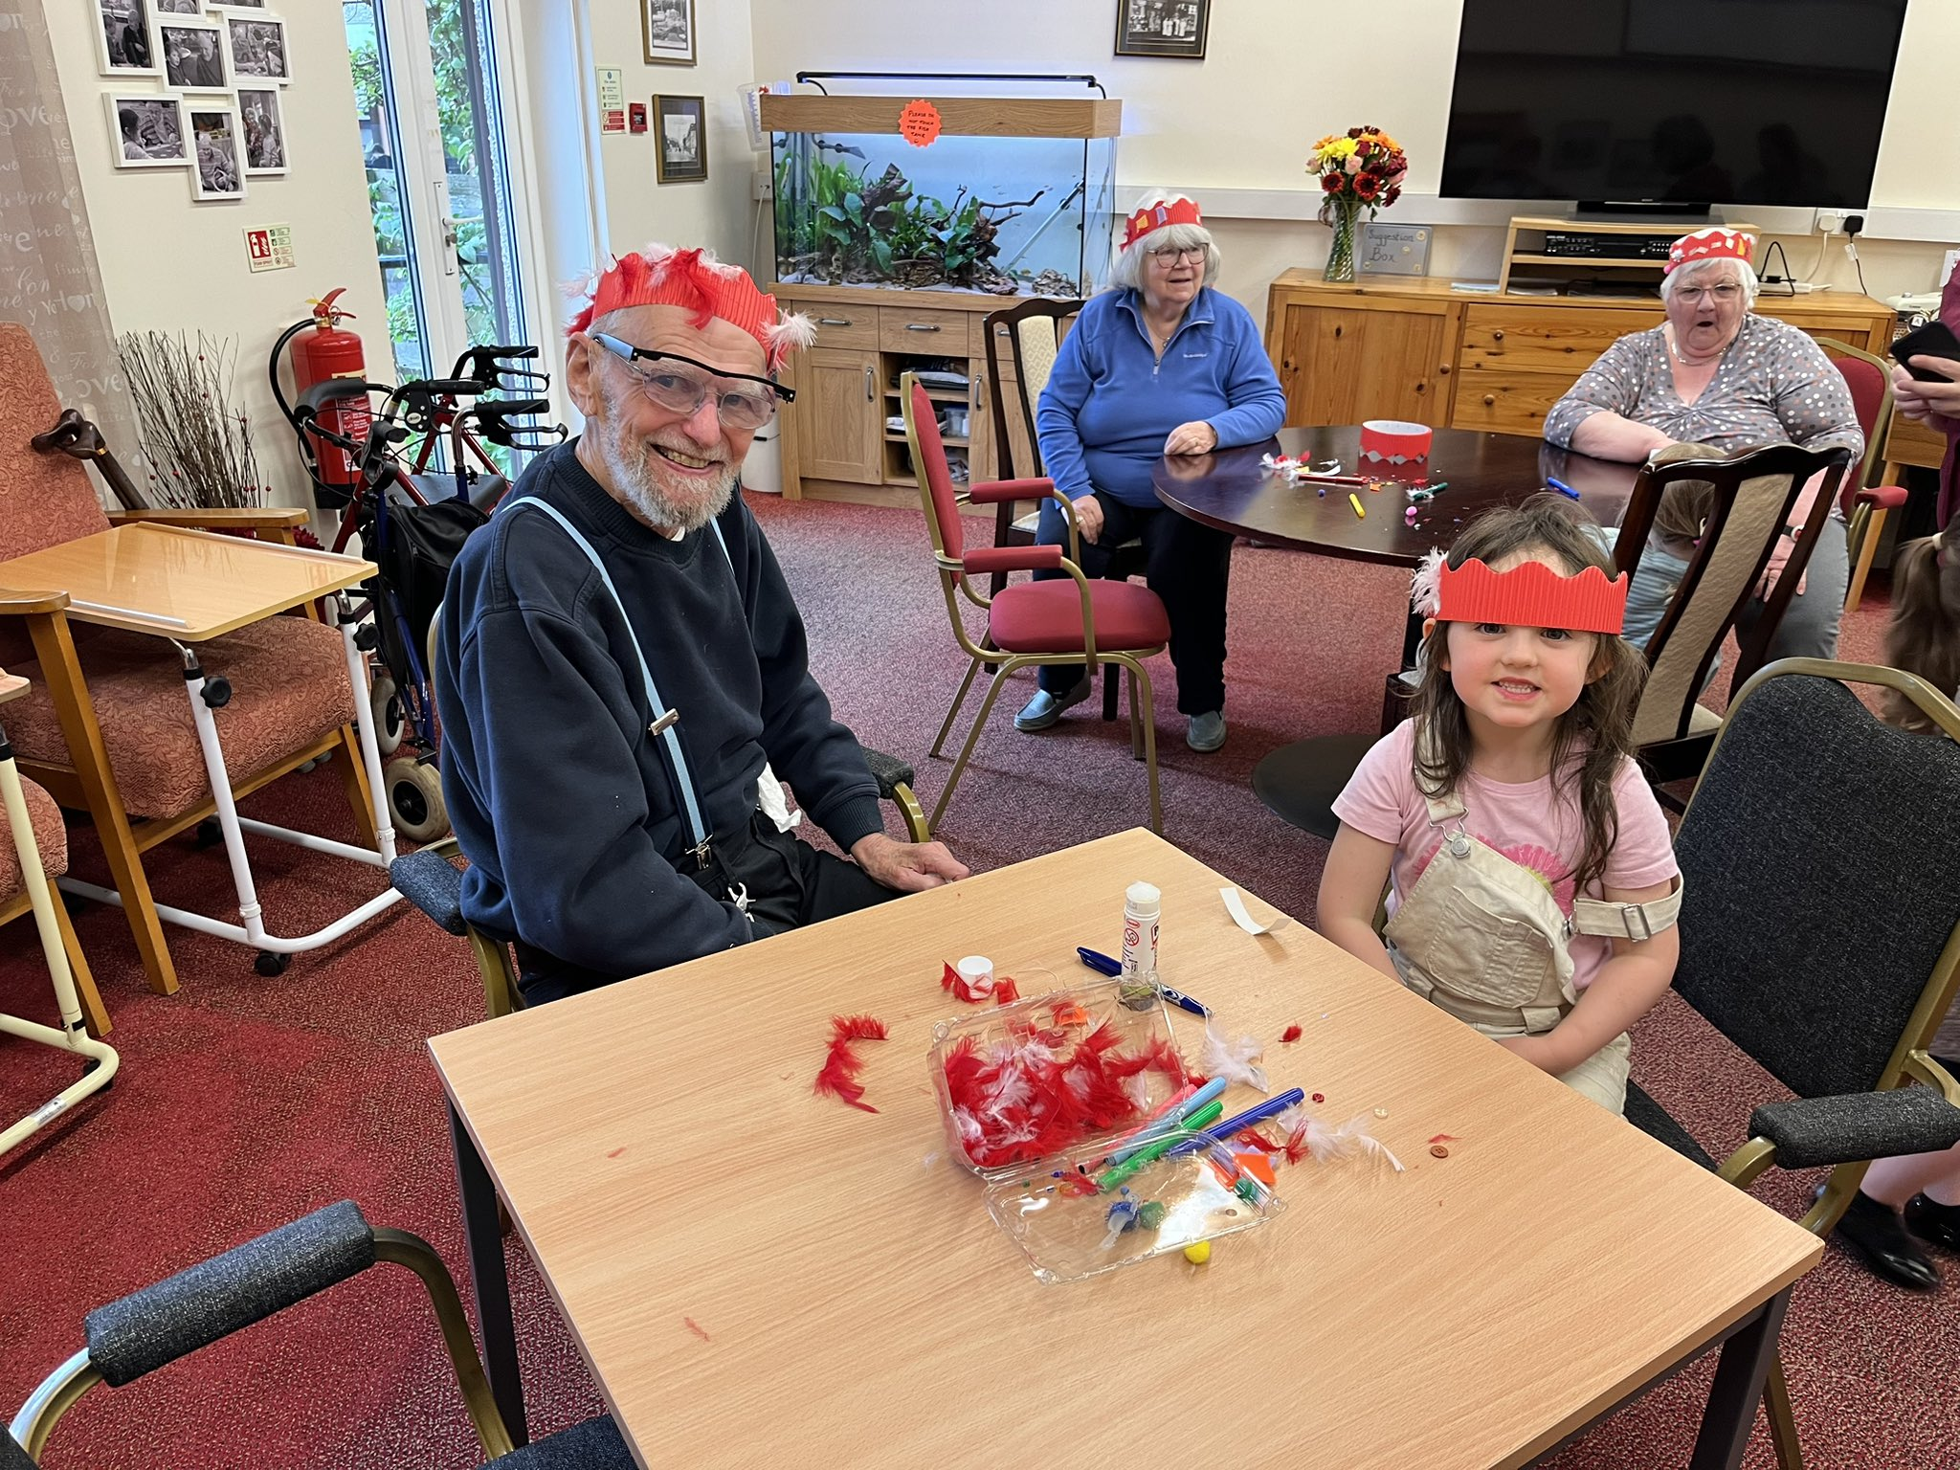
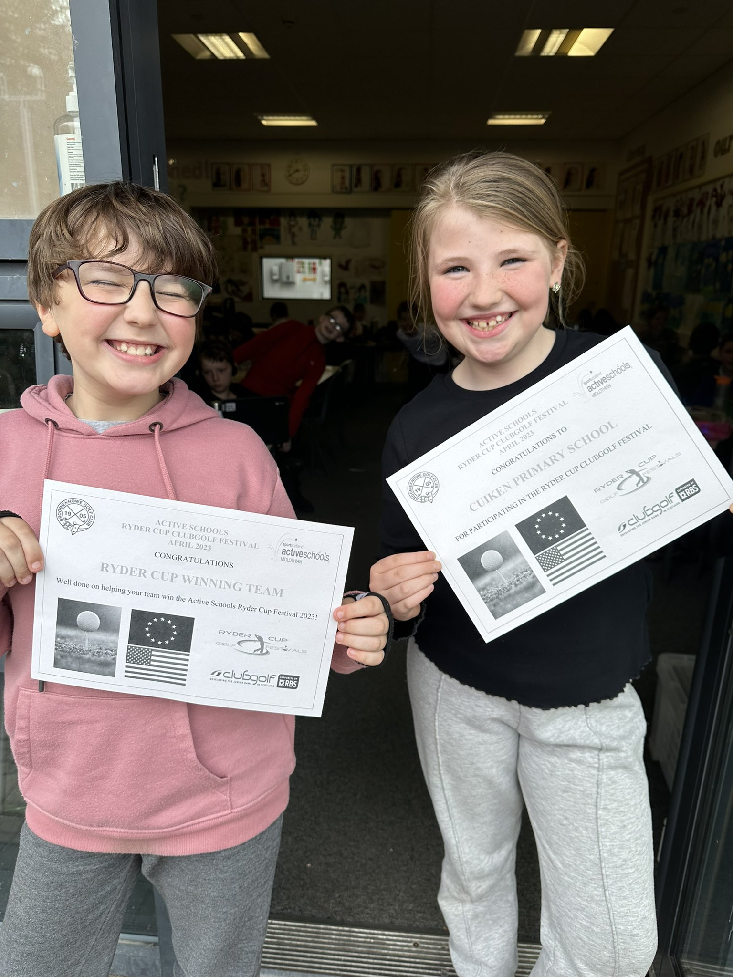
Capacity for continuous improvement 2-18
Primary, secondary & special schools
QI (HGIOS4 and HGIOELC) | QI 1.1 Self-evaluation | QI 1.3 Leadership of change | QI 2.3 Learning, teaching and assessment | QI 3.1 Ensuring wellbeing, equality and inclusion | QI 3.2 Raising attainment and achievement
Themes | - Collaborative approaches to self-evaluation  - Analysis and evaluation of intelligence and data  - Impact on learners’ successes and  - achievements | - Developing a shared vision, values and aims relevant to the school and its community  - Strategic planning for continuous improvement  - Implementing improvement and change | - Learning and engagement  - Quality of teaching  - Effective use of assessment  - Planning, tracking and monitoring | - Wellbeing  - Fulfilment of statutory duties  - Inclusion and equality | - Attainment in literacy and numeracy  - Attainment over time  - Overall quality of learners’ achievement  - Equity for all learners
School self- evaluation | 3 satisfactory | 3 satisfactory | 3 satisfactory | 3 satisfactory | 3 satisfactory
Local Authority or Collaborative Review evaluation | Not evaluated | Not evaluated | 3 satisfactory | Not evaluated | Not evaluated
HMI/Care Inspectorate evaluation | Not evaluated | Not evaluated | Not evaluated | Not evaluated | Not evaluated

Early Learning and Childcare Delete if not applicable.
If your school has an ELC setting, you do not need a separate early years school improvement plan but need to ensure there are clear priorities for your ELC . The Care Inspectorate expect improvement plans to be clearly referenced to their Quality Framework as well as HGIOELC. See table below which will support with this.

The National Standard for Early Learning and Childcare | Care Inspectorate - Key Question Measurement | Care Inspectorate Quality Indicators - Key Quality Indicators for inspection | HGIOELC - Key Quality Indicators for Inspection | Self-evaluation
Criteria 1  The appointed Early Learning and Childcare Setting will have a high Quality Workforce. | Care Inspectorate evaluations are “good” or better on the key questions “how good is our staff team?” and “how good is our leadership?” | 4.1 - Staff skills, knowledge and values  4.3 - Staff deployment*  3.1 - Quality assurance and improvement are led well | 1.3 – Leadership of change  2.3 – Learning, teaching and assessment | 4 good
Criteria 2  The appointed Early Learning and Childcare Setting will demonstrate an ability to support outcomes for children in relation to all aspects of their development. | Care Inspectorate evaluations are “good” or better on the key questions “how good is our care, play and learning?” | 1.1 - Nurturing care and support  1.3- Play and learning | 2.3 - Learning, teaching and assessment  3.1 – Ensuring wellbeing, equality and inclusion  3.2 – Securing children’s progress | 4 good
Criteria 3  The appointed Early Learning and Childcare Setting will have the right physical infrastructure, both indoors and outdoors to improve outcomes for children | Care Inspectorate evaluations are “good” or better on the key questions “how good is our setting?” | 2.1 - Quality of the setting for care, play and learning | 2.3 - Learning, teaching and assessment  3.2 - Securing children’s progress | 4 good

Section 3: Improvement Plan 2023-24

Establishment | Cuiken PS
Associated School Group | Penicuik
Session | 2023-24
Prepared by | Kimberley Hughes
Date | 12 June 2023
Reviewed by | Name Sally Ward/Julie Fox
Reviewer recommendations | SQIP agreed
Date signed off | Date Aug 23

Midlothian Education Service Priorities

Why?  Our vision | All children, young people, adults and communities in Midlothian are supported to be the best they can be. This will be achieved through a nurturing, respectful and collaborative approach that promotes wellbeing, equity, inclusion and lifelong learning.
What?  Our improvement priorities | Raising attainment to ensure that all children and young people in Midlothian achieve outcomes which lead to positive destinations  - Learning, teaching & assessment  - Curriculum  - Equity | All children & young people feel valued & included, and have the same opportunities to succeed  - Relationships  - Wellbeing & care  - Inclusion & targeted support
How?  Our improvement drivers | - Continuous professional learning for all colleagues  - Data which drives improvement  - Quality improvement framework  - Strong leadership at all levels  - A children’s rights-based approach  - Digital empowerment

Raising attainment to ensure that all children and young people in Midlothian achieve outcomes which lead to positive destinations
- Learning, teaching & assessment
- Curriculum
- Equity

Where we are in Summer 2023 | By Summer 2024 | By Summer 2027
All teachers are implementing the school’s agreed effective features of learning, teaching & assessment. | All teachers regularly moderate the planning, delivery and assessment of learning and teaching. Accuracy of teacher judgements of achieved levels is secure. | All teachers are confidently able to moderate the planning, delivery and assessment of learning and teaching.  Teacher confidence in planning targeted support for our learners at risk of not achieving.

Key Actions | Lead Person | Timescale | Expected measurable outcomes for learners
Embed new planning formats | SLT | 2023/24 session | Coverage, depth and differentiation is clearly visible resulting in better outcomes for learners
TfW nonfiction training and introduce Drawing/Scribble club | DHT  Literacy leads | 2023/24 session | Progression in writing is more evident from ELC to P7 so learning and teaching is more specific to pupils, thus resulting in more measurable progress in writing.  .
Improved and more regular quality assurance | SLT | 2023/24 session | Consistent learning and teaching across the school therefore meaning equity for pupils and ideally improved attainment.
More regular assessment and moderation sessions in school and across ASG. | SLT | 2023/24 session | Teaching staff will be more confident in their ability to assess achievement of a level therefore learners will have access to teaching that is linked to their next steps  There is a more consistent approach to assessment across the ASG which will directly impact on P7-S1 transition.
Regular observe and evidence of clear differentiation | SLT | 2023/24 session | Pupils can access learning that is specific to their needs offering support and/or challenge.
Embed use of digital technology to enhance teaching and learning | HT  Digital leads | 2023/24 session | Pupils will all have the same opportunities with digital learning, and develop the associated skills.

All children & young people feel valued & included, and have the same opportunities to succeed
- Relationships
- Wellbeing & care
- Inclusion & targeted support

Where we are in Summer 2023 | By Summer 2024 | By Summer 2027
All teachers are implementing our positive relationship policy and have a good understanding of our pupils. | All staff have embedded our positive relationships policy and are using Rights based approaches. | Children’s Rights are embedded into the ethos of the school and the learner voice is evident in all areas.

Key Actions | Lead Person | Timescale | Expected measurable outcomes for learners
Embed HWB progression from Pauline Lawson EmotionALL | DHT and Pauline Lawson? | 2023/24 session | A consistent approach to HWB for all learners which allows them to build upon skills year on year.
Review and embed anti-bullying policy and log | SLT | 2023/24 session | Learners feel safe and heard in school.  Pupils have a good understanding of what bullying is, and how to address it.
Inclusive classrooms and consistent visuals | SLT  Claire Maguire  ASN | 2023/24 session | Children and families feel that our school environment is accessible and promotes learning for all.
Extend use of Rights based language and highlight how Rights are enacted in Cuiken | DHT and Rights Leads | 2023/24 session | Children are aware of their Rights and can see they are enacted in school.  Children feel that their voice is heard and evident in decision making in school.
Engage with outside services to create opportunities for success for our learners outside of classroom based learning. | AHT | 2023/24 | Children can experience success in different contexts.  Children have opportunities to learn about themselves in different ways.

Improvement drivers
Please briefly explain how you are embedding the 6 drivers in 2023 - 2027.

Continuous professional learning for all colleagues
How is continuous professional learning enabling you to achieve your school improvement priorities?

SLT
- DHT/PT Network meetings
- HT Meetings
- QAMSO training
- Stretch Aim drop in sessions
- SALT sessions
- Stephen Graham Teaching Writing

All SLT CLPL professional learning opportunities have been closely linked to our priorities, mainly based around data and how best to interact and use it to spot gaps and increase attainment.
The DHT network meetings have been useful for networking with colleagues, and beginning to understand inspection standards and expectations. However, we would all like to learn more about this.
The HT meetings have been useful for me as a first time HT to network with other head teachers, and learn more about the authority's priorities. I found the sessions on SEEMIS data particularly helpful.

Teaching Staff
- SEIC Research Schools
- CAT sessions
- Professional Learning Academy training

Staff engaged very productively with Research Schools, and although they did not find all the sessions valuable, the professional enquiries conducted were of high quality and directly impacted on some pupils. Some of the research and strategies used will also continue and be developed in the coming session eg. Talking Mats

Learning Assistants and Support Staff
- Authority training during strike days
- CP
- First Aid

Our learning assistants and support staff always engage with CLPL enthusiastically and were noted as a strength to our school. The staff are always keen for more opportunities that work in with their agreed working hours.

ELC
- Drawing and Talking Club
- Women’s Aid training
- Introduction to Signalong
- Visual Timetable training from SALT
- Supporting children with food and eating training

All of the CLPL undertaken by the ELC this session has directly impacted pupils and their families. The ELC staff have been really responsive to the needs of our community and use CLPL as a way to impact the nursery and the wider community by leading information sessions with families. The Drawing Club training was particularly useful as we have now adapted some school literacy planning to incorporate this and have more overlap with the ELC.
Data which drives improvement
Dashboard
How are you using data to drive school improvement?

Our regular data dialogue meetings have allowed us to track pupil and class progress more closely. Staff are becoming more confident interacting with data, and can discuss achievement in a more meaningful way. By unpicking our data, we are able to address gaps quickly, whether through a teacher or Learning Hub intervention. We are also able to spot trends/patterns that we can then predict and address as a whole staff.

Quality improvement framework

learning rounds
What quality improvement activities do you have planned for the session?

We want to have a very focussed quality assurance calendar that includes work sampling, pupil voice, classroom observation and planning reviews.
Strong leadership at all levels
How will leadership be developed across your school during the session?

All class teachers will take on a co-ordinator role within the school which they will lead on. This role will include dedicated assemblies, whole school tasks, possibly CAT sessions and focus days across the year. Staff have selected their roles based around things discussed at their PRD. The roles range from literacy and numeracy coordinators to nurture, play and community engagement.

We also hope to build on the research undertaken this year whilst doing Research Schools. Staff have shown an interest in learning more about some of the techniques and strategies used by other class teachers to target the gap in their classrooms. We hope to build capacity by sharing these examples during staff/department meetings and/or CAT sessions.
A children’s rights-based approach
How will you continue to embed UNCRC within your school?

We already do a lot of this but we need to make it more explicit. We aim to ensure that children don’t just understand the right, but see how that is enacted in Cuiken. We will encourage pupils to find examples and create displays. This will help us to identify gaps where pupil voice will then lead on how to address that gap. We will use pupil voice groups and assemblies to look at less familiar Rights and build pupil knowledge of them all. We have two class teachers who will attend the UNCRC meetings, and we will consider whether the school award is something we want to proceed with this session.
Digital empowerment
What are your digital inclusion & learning priorities

We want to create a digital policy that will incorporate the use of digital, but also the assessment, moderation and quality assurance aspects. We want a clear policy that staff, pupils and families can understand. We want to explore how the use of digital can influence the achievement of a level in some curricular areas, and how we ensure those identified pupils are developing literacy skills without digital too.

We have been using our digital devices as a bigger part of our reporting, and we hope to extend that again this session, but with more detail and input from families.
All teaching staff and pupils are using digital devices, but we want to ensure they are embedded in high quality learning and teaching, and move away from the use as an end of task activity. We also want to spend time upskilling our LA team so they can support in this area more.

Associated School Group Improvement Plan

Where we are in Summer 2023 | By Summer 2024 | By Summer 2027
Most ASG schools are working towards a consistent approach to the learning, teaching and assessment of Numeracy and Maths.  Most Pupils experience similar learning experiences across the ASG.  Many ASG teaching staff feel confident in identifying levels achieved and using varied assessment to inform decisions. | Almost all ASG schools are using a consistent approach to the learning, teaching and assessment of Numeracy and Maths.  Almost all Pupils experience similar learning experiences across the ASG.  Almost all ASG teaching staff feel confident in identifying levels achieved and using varied assessment to inform decisions. | All ASG schools are using a consistent approach to the learning, teaching and assessment of Numeracy and Maths.  All Pupils experience similar learning experiences across the ASG.  All ASG teaching staff feel confident in identifying levels achieved and using varied assessment to inform decisions.

Key Actions | Lead Person | Timescale | Expected measurable outcomes for learners
1. Collect and analyse Numeracy curriculum data from all ASG Primaries and S1/2 at PHS  This will give an overview of each school’s learning, teaching and assessment approaches as well as attainment and allow for bespoke support to be provided for all schools. | Claire Hadden | August/ September 2023 | ASG HT gp. need to discuss dashboard date to set a stretch aim
2. Create a calendar of CLPL events to increase staff confidence and understanding of ASG approaches  Training available both in person and virtually for all staff on identified outcomes. Additional CLPL available through ASG website. Direct support also offered to staff in a coaching capacity and Numeracy Pupil Leaders used to support and enhance Numeracy experiences across classes. | Claire Hadden | ongoing | 90% of staff have finished training and report a high level of confidence in understanding the strategic plan and approaches taken as measured through survey/ staff evaluation of training.
3. Facilitate in school and ASG Numeracy moderation  Identify key dates for in school moderation using Numeracy moderation format and facilitate an ASG moderation event. This will develop a deeper understanding of the level a pupil is working at and what achievement of a level looks like. | Claire Hadden | term 3 and 4 | Most staff report being confident in using moderation formats and making decision about achievement levels as a result of taking part in ASG moderation events in numeracy ( moderation training evaluation formats - analysis of reported outcomes)
4. Develop a consistent approach to transition (of Numeracy information) from Nursery - P1  Identify key numeracy information for transition and support ELC staff with assessment in Numeracy to ensure consistent information is being shared between Nursery and P1. | Claire Hadden | 2023-24 session | Most ELC staff report they are confident in assessing numeracy progression for children in their setting and are familiar with the key numeracy information they need to transfer between Nursery and P1

Associated School Group Improvement Plan - Part 2 - Big 5 Project

Where we are in Summer 2023 | By Summer 2024 | By Summer 2027
Many teachers are now familiar with the ASGs agreed learning & teaching strategy - The Big 5 Project and associated pedagogies | Almost all teachers are now familiar with the ASGs agreed learning & teaching strategy - The Big 5 Project and associated pedagogies and are starting to implement them deliberately and consistently in their practice | All teachers are now familiar with the ASGs agreed learning & teaching strategy - The Big 5 Project and associated pedagogies and are starting to implement them deliberately and consistently in their practice

Key Actions | Lead Person | Timescale | Expected measurable outcomes for learners
1. Hold an ASG CAT - Carousel / market place activity to launch and introduce Bug 5 to all Primary ASG Colleagues. Event led by DHT/ PHS WG and other staff input | C.Biddick | Delivered September 2023 | Almost all staff report they feel confident in identifying the Big 5 areas and are starting to use the Big 5 strategic approach in class with some support
2. Set up an ASG Learning and Teaching Working Gp. to support initial work in rolling out the Big 5 in ASG Primary schools through an agreed development plan from 2023- 2027 that:  Supports staff to implement the Big 5 in their daily practice, develops student understanding of what the Big 5 are as they enter upper Primary and assists teaching staff to evaluate their teaching through Big 5 student evaluation formats and collects quality assurance information to assist evaluating QI 2.3.  *Schools could share a common Big 5 Google landing site from their own websites. | A Proctor/ C Biddick / ASG HT  Staff reps. Penicuik ASG school | September 2023 AND Ongoing | A working gp is set up and is of training.

